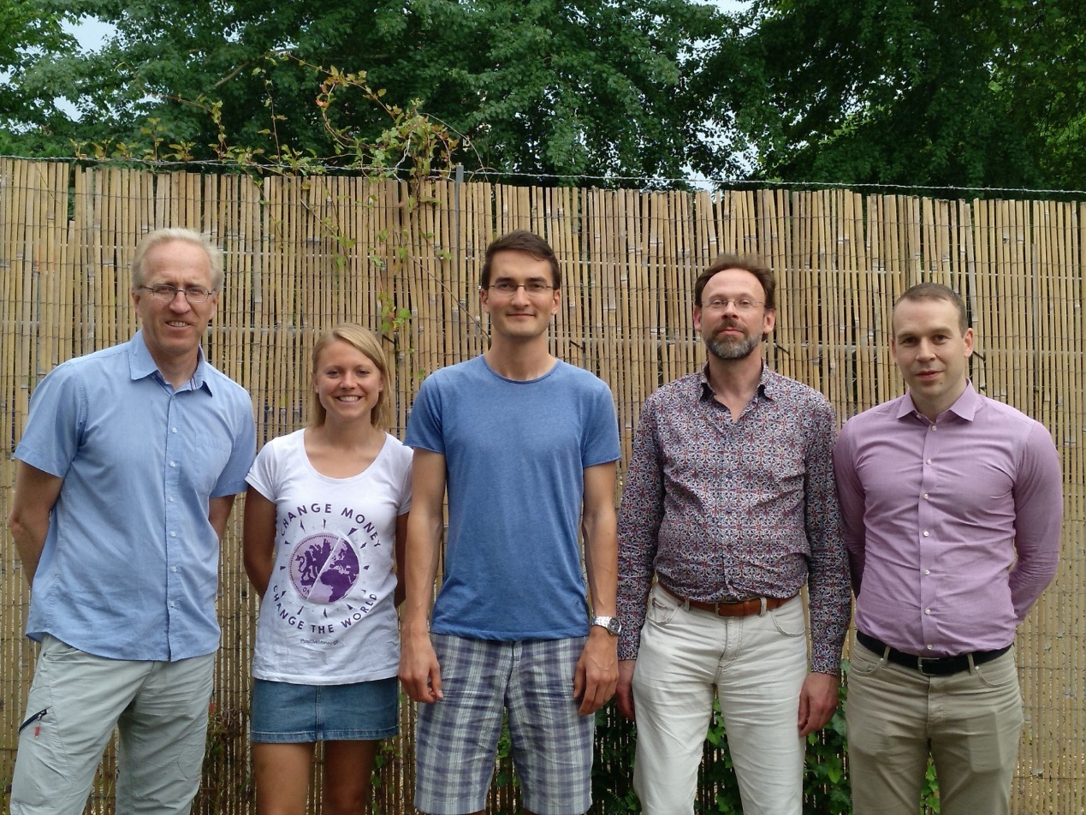

CORE LEADERSHIP GROUP:
IMMR:

LARS, SWEDEN
RACHEL, UK
LINO, GERMANY
EDGAR, NETHERLANDS
SIGURVIN (VINNIE), ICELAND

