The nature of money, and the money system, is not taught in our schools or discussed in our media. This confusion of what money is, and from where money comes, does a disservice to all of us, because our current monetary system is the **ROOT CAUSE** of major injustices in our society – the prosecuting of several wars simultaneously and the siphoning of our wealth to the 1% while poverty greets more and more of our people. Whoever creates a nation’s money has great power to do good (such as funding single payer healthcare) or great power to do bad (such as funding corporations that privatize our public services). In sum, the privilege to create a nation’s money bestows great wealth and political power.

To understand the effects of a monetary system, one needs to look at history. It is only over time that these effects can be seen.

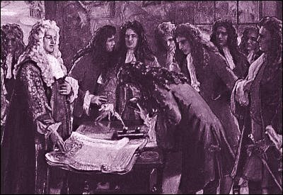

1694 Parliament allowed the private Bank of England to print its own banknotes, loan them out at interest, and the government would accept them for dues & taxes.

William Patterson, the bank’s founder, famously said: *“*[*The bank hath benefit of interest on all moneys which it creates out of nothing.*](http://www.azquotes.com/quote/582455)*”*

The same can be said about our U.S. commercial banking system.

ENGLAND

The story of American money begins in England in 1694. At that time, William III was on the British throne. William, who had come from Holland, wanted to fight a war to protect his ancestral country, but there wasn’t enough money to do that. How was William to pay for this war?

At this point, some influential people entered a bill into Parliament, which included a charter for a private corporation called a bank --- this corporation to be called the ‘Bank of England’. According to the charter, the bank would loan gold and silver worth 1.2 million pounds to the King, at 8% interest. But, in addition – and this was the hidden surprise – the bank was to receive the privilege to print its own private banknotes – **another** 1.2 million pounds worth – and loan these banknotes out at interest, not the King, but to the public. The private banknotes were to circulate as money, and be accepted for government payments.

Well… The bill was passed.

* The King got his **war**.
* The nation got the beginning of a **permanent** **national debt**.
* The bankers got the **privilege to create private bank money and loan it at interest to the public**. And, of course, the first banknotes were taken into Parliament to bribe the politicians. You see Parliament was the only institution that could change the law and take away the bank’s privilege to create their money.

Slowly over time, the private banks created more and more of the nation’s money, first as banknotes, then as accounting entries in checking accounts, all as loans to the public with interest.

Slowly over time, the debts of the government and citizens grew and grew.

Slowly, the ability of the government to meet the needs of its people was less and less.

And slowly, the wealth of the country concentrated in the banks and the powerful corporations they funded.

UNITED STATES

The American colonies, however, rejected this system of private bank money. They refused to charter private banks. All 13 colonies issued sovereign public money direct from their colonial legislatures. The colonies prospered as their public money circulated to encourage trade, crafts and farming.

But Parliament, under the control of the powerful Bank of England, outlawed the colonial sovereign money, first in 1751, and then the harshest law in 1763.  Ben Franklin claimed that within one year, the colonies were filled with unemployment and beggars, just like in England. The result was the Revolutionary War.

We won that war. Our new constitution, under Article 1, Section 8, gave Congress the power to create our money. However, a political war continued. Throughout the 1800’s, the most important national issue in the new United States was the money question – public versus private creation of the money supply. But, in 1913, the Federal Reserve Law was passed. This law created 12 Federal Reserve Banks, again with a misleading name making them appear to be part of the government. But every single share of these 12 corporations is owned by their private member banks, with names like Citibank, and J.P.Morgan Chase. And, again this law had a hidden surprise -- the privilege and responsibility for creating our nation’s money was handed over by Congress to these same member commercial banks and their private bankmoney.

Well… what has been the result for the U.S.?

* Funding of two world **wars** and today’s **perpetual war**
* **A permanent national debt**, now close to 20 Trillion dollars
* **Numerous financial crises** – the most extreme the Great Depression and the Collapse of 2008, where 10 million families lost their homes to foreclosure *(National Center for Policy Analysis)*
* Massive inequality and poverty, where the average US household owes more than $16,000 to credit card companies, $173,000 on its mortgage, $28,500 on its car, and $49,000 in student loans
* And the funding of **multinational corporations** to create cheap products thru cheap labor - eliminating American jobs and reducing living standards

And remember, the bankers have taken their bankmoney into the halls of Congress and bought off our politicians.

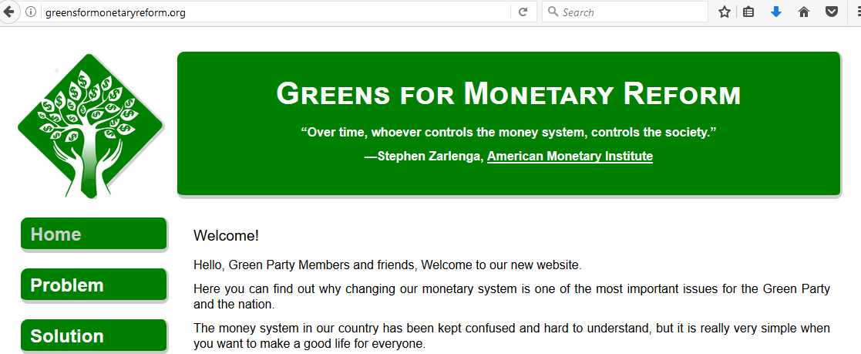

THE SOLUTION: GreensForMonetaryReform.org

But there is most definitely a solution for our nation –which overnight converts this bankmoney system to a reliable U.S. sovereign money system. In this solution, everybody’s money is maintained safe and secure, and all debts are payable.

Please look at our website GreensForMonetaryReform.org which explains the Green Party monetary reform plank, “Greening the Dollar”. This plank was based on the work of Stephen Zarlenga and the American Monetary Institute. In 2008, with the help of Missouri Greens Dee Berry and Ben Kjelsus, it became part of the party’s platform. The reform went through three years of legal review in Congress, and emerged as the NEED Act, (N – E – E – D) The National Emergency Employment Defense Act. Dennis Kucinich courageously introduced this bill to Congress in 2010 and 2011. It is the first plank of the Green Party Platform to be made into an actual bill in the U.S. Congress.

The website will explain the PROBLEM of private bankmoney, the SOLUTION of sovereign public money, and the elegant TRANSITION from the private to the new public system. The HISTORY tab offers you learning materials for Stephen Zarlenga’s book, THE LOST SCIENCE OF MONEY, which was foundational for both the Green Party ‘Greening the Dollar’ plank and the NEED Act.

Let me conclude with describing the structural reform in “Greening the Dollar”. The solution has 3 parts, and a study of history has proven that all 3 must be done at the same time for the monetary power to remain in public control:

* The government buys all shares in the 12 Reserve Banks, putting them in the U.S.Treasury.
* The private commercial banks are no longer allowed to create money. This is accomplished by a change in the federal accounting rules.
* Congress creates sovereign money, spends it for public needs, and in the process creates tens of millions of jobs.

I end with a quote from one of the students from the LOST SCIENCE OF MONEY course:

What we use as money is created by private commercial banks, whenever they make a loan – all with interest to the banks. This is capitalism’s most essential feature and completely missing from the study and definition of capitalism.

The End.