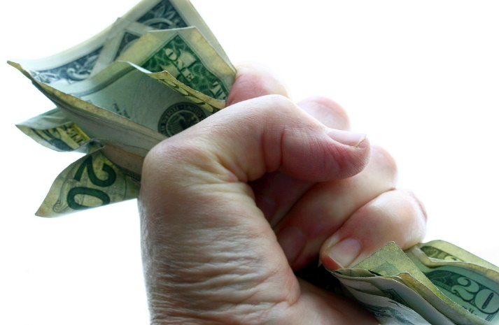

MONEY, POWER, POLITICS,
WEALTH and EQUITABLE TRADE
in ECONOMICS

