2025-4-27 Minutes: Sun AMI Parity meeting

Participants:
Lee Kochel Mike Holden
Geri Perry Joe Bongiovanni
Sue Peters Joe Polito
Randy Cook Steve Walsh

OLD BUSINESS:

OUTLINE FOR ‘OLD BUSINESS’ (below):
- agenda
- design of parity pages
- parity articles
- parity welcome page
- parity pictures
- Joe’s blog page

1. 2025-4-6 Agenda:
1. ACTION ITEMS: Discuss action items above and any material submitted for these action items.
2. ACTION ITEM - BLOG: Discuss material from Joe B. for the Parity Page BLOG.
3. Joe P: does he want to talk about his addition to minutes 2025-3-30?
4. Joe P: he suggested in email to group: “Perhaps we should do a joint study with the RPC on Patman's money primer.“ .

2. 2025-3-30 Design of parity pages. Group decided to leave the word ‘parity’ in the AMI main menu. When reader clicks on ‘parity’, he goes to the Parity Welcome Page. At the top of the Parity Welcome Page, there are links to the other parity pages, 2025-4-6 Updated Design of parity pages:
Based on the AMI parity meeting today, 2025-4-6, the parity pages have been expanded. Here is the updated listing of parity pages:
Parity Welcome page (aka Parity Home page); at top of page are ‘heading bar’ i.e., links to:
    - beginning articles
    - parity history; at top of page are ‘heading bar’ i.e., links to:
- French Physiocrats 1700s
- American populists 1800s
- Kuznets
- Soddy
- George Peek
- Carl Wilken
- NORM
- Charles Walters
    - how parity economy works
    - agriculture’s economic importance
    - parity BLOG
    - parity games
    - parity book reviews
    - parity resources (handouts, etc.)

2025-4-6 Steven suggested a new parity page for parity acronyms.

3. 2025-4-6 ACTION ITEM; Parity Articles/pages. Here are some suggestions:
- Lee volunteered to write review of book on physiocrat Quesnay, based on manuscript by woman friend of Randy’s from Arizona.
- Sue: book reviews of parity books, to encourage people to read them. On new book review page.
- Mack Arrington’s sell sheets and other handouts. On new resources page.
- Randy’s suggested article: how a parity economy would have jobs for people being laid off by Elon Musk. Give ideas of local industries that could develop. Sue: bring regeneration for local culture and small towns. Randy: issue is how to make the land required available to those who are willing to do the work. Geri: new laws will take time to work the change of society and people.

4. 2025-3-30 Group discussion of new Parity Welcome page – text updated by Randy. Discussed Welcome page updated by Peek Group. Randy shared the updated version, showing deletions crossed out and additions in square brackets. Randy read the updated version. The group liked it. Randy will clean up the paper by removing the indicated deletions, and send it to the group. Steve will take this copy and play with it. Joe P. thought the Parity Welcome Page should be more simplified for the general public, who don’t know the concepts and need the implications for their lives. Geri said that everyone in the group can look at the final copy that Randy will send out and look at it again and make your suggestions.

5. 2025-4-6 Group discussed pictures for ‘rolling banner’ for Parity Welcome Page:
Steve – need 4 or 5 pictures; people displayed pictures:
- Lee showed pictures from 2021 AMI talk by Geri – there were pictures showing different raw materials ; these pictures were gotten by Geri from Tabitha; 14 min 01 sec into Geri’s talk; Lee to contact Tabitha if these photos can be used individually without copyright; Randy – these 6 pictures could be a rotating ‘playlist’ on on the Welcome Page. Steve – show the bodies of fish on the fishing picture. Steve – show something growing in the farming picture.
- Geri showed pictures from her family trip into S. Dakota farm country. Examples: mill, field of corn stalks, livestock farm, field & pond, tilled roads, chickens, etc. These could be a rotating ‘playlist’ of ‘South Dakota Farms’ on the Welcome Page. Since the photos are from Geri and her family, they can be used on the webpage for free.
- Sue showed two images from Mack Arrington’s handouts:

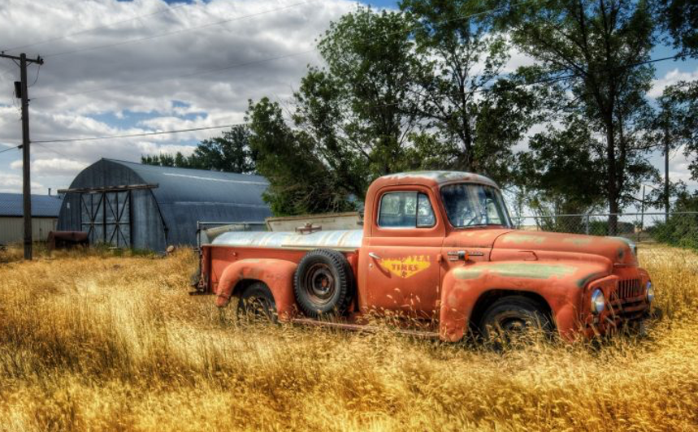
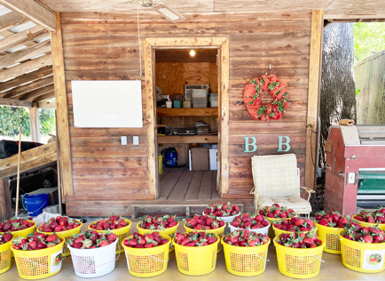

Sue will check with Mack Arrington, if both these photos can be used by us without cost.

- Randy showed his photos: field with rainbow, cherry trees and peach trees in bloom, etc. The playlist theme could be ‘growing fruit’. They are all his photos and can be used without cost.
- Steven will look at his old photographs during the week.
- Mike: he said he could go around his Minnesota farms with corn and soy, grain elevators, fields. This could be a playlist called ‘grains’. Randy: bulk commodities (those that are most of the crop acreage) are the important crops to regulate at parity because they have the greatest impact on gross farm income. Grains become food for humans, feed for livestock, and fiber for fabric. Mike: could have ‘disparity’ playlist of small-scale farm pictures versus cafo pictures (showing exploitation).

6. 2025-4-6 Joe B’s blog page:
- Article: Joe B had sent a long article during the week to the group. Joe B said this article may be an anchor for the blog, to excite people’s interest, but he was open to shortening it with help or splitting it into several articles. Steven said he had been reading the article and two ideas stand out: 1) lawful rights to parity had been taken away from farmers – also farmers have a right to choose parity or not 2) theme of national income parity.
- Picture: Joe B said he saw a picture at the top of the blog page – perhaps the picture of Mary Sanderson’s father’s gravestone with the word ‘parity’ on it. He will ask Mary. Joe B also said he would like people’s help with the graphics.
- Joe P.: the article should be more concise, to help the person, new to parity, coming to the blog. He suggests pictures of parity’s productive activities. Randy: The Standard Enhanced Industrial Classification (SEIC) would have a listing of the industries.

NEW BUSINESS:

2025-4-27 Randy shared the agenda for 2025-4-27. The last parity minutes were for 2025-4-6, due to a week of RPC (4-13) and a week of Easter Vacation (4-20).

2025-4-27 BMRC discusses Parity Welcome page. Wiseview removed black & white bar and changed the font for the title ‘Par Economy’. Sue’s six pictures of the different areas of raw materials production have been put below the title. Sue found 5 of the pictures on slide #5 of a presentation from the 2021 IMMR Conference: https://infostation1.net/1/sue/2021-03-21%20SUN%20IMMR%20CONF%20-%20presenting%20PARITY%20for%20AMI/ Geri: the current text on the Welcome Page is not the updated text from Randy; that needs to go up on the Welcome page in place of what is there now.

2025-4-27 BMRC discusses obtaining photo rights for any pictures up on AMI parity pages.
There is real concern over using photos from internet, without getting permission where legally required. Mack got fined $400 for this. AFJM also had to hire a lawyer and fight against an organization which threatened to sue them. Geri – best to get free photos. The following websites were discussed, for investigation publishing rights of photos:

- Mike: use images.google.com. Go to url. On the search bar, click on the symbol of a camera.

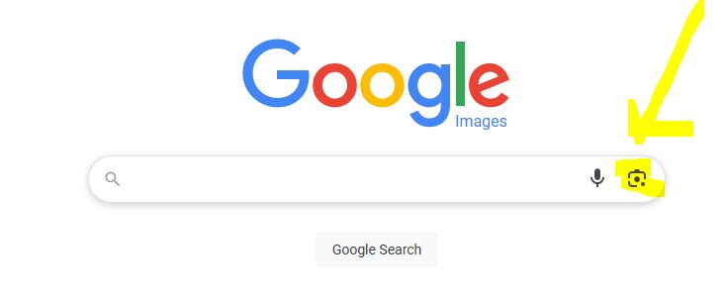

Then, copy/paste the image into the ‘search image link’ that is displayed. To practice, use
Randy’s image of the farm gear on the larger economy gear from Parity Welcome page.

- Suggestion from Tom Rodman, BMRC, on using images.google.com: type in search description. Example: enter ‘signing charter of Bank of England’; click ‘images’; click ‘tools’; click ‘usage right’; click ‘creative commons license’.

- Here are some suggested websites from Mack Arrington for free photos for our parity pages:

https://www.pexels.com/
https://pixabay.com/
https://unsplash.com/
https://openverse.org/

- Mike: use Shutterstock.com

Even if an image has a ‘Creative Commons license’, still look up image and see if free. Even if the image is over 75 years old, still look up image and see if free. Geri: each must do due diligence for our pictures up on parity pages.

2025-4-27 Discussion of difference between Blog page versus parity articles. Steve explained that the main AMI website had a blog, found by clicking ‘resources’ on the main menu; in the dropdown menu, click ‘blog’. It is structured as short articles followed by a request for comment: ‘Leave a reply – comment’. Currently, below the Parity Welcome page, are 4 articles, with a similar request for comment at the bottom. Steve calls this a blog.

Geri: on the parity pages, the articles are not blogs, but ‘articles’. There needs to be a separate ‘BLOG BUTTON’ on the parity links, where the reader can go directly to Joe’s article and have a two-way discussion on parity with Joe, a real person. Steve: design the location of the BLOG BUTTON on the parity pages, and Steve will use it. Steve: Wiseview may be able to ‘knock out bots’ before they get to Joe.

Joe: want certain two-way communications on parity, so title would be “Please, join the conversation - Parity Blog”. Would be first button under Welcome paragraphs. The first article the audience would see would be Joe’s article, with the invitation to start the conversation. Geri: Joe will design blog as a conversation, plus responding to the comments from the other parity articles on the other parity pages. There is a difference between Joe’s Blog and the other parity articles, which don’t have to be long and can have formal or informal footnotes.

Geri: suggested text for Blog Button as: “Please join the conversation and ask your question. Get a reply from a real human being.”

Steve: all parity articles will have comment section at bottom. Joe agreed to accept and evaluate all these comments, along with his blog conversation.

2025-4-27 Geri’s homework to all: each member practice on the photo-rights websites (see above from Mack and others). Find suitable images for Welcome Parity page for next week but investigate rights. Keep record of photo rights.

Meeting ended: 10pm et Next meeting: 2025-5-4

Tentative Agenda – 2025-5-4
1. Geri wants to understand better the placing of the links at the top of the parity pages.
2. Geri wants to discuss design of articles on article pages.
3. Steven: needs final design of parity BLOG BUTTON.
4. Within two weeks from 2025-4-27, AMI needs to have ‘free’ photos, to replace the current 6 photos on the Parity Welcome page, which have not been sourced as free to use.
5. All: are there any past articles that you found you would like to upload to the parity article pages?
6. Review updated design of parity pages.
7. ACTION ITEM: look through Randy’s text for Parity Welcome page and come prepared with your suggestions.
8. Geri: would like to discuss the articles on the Parity Welcome page; she thinks each person should have 1 article there.
9. Geri: would like to change title of Parity Welcome page to: Welcome to Par Economy – or – make it links with the first link being ‘Welcome to Par Economy’.
10. Geri: we need to remember to include a link to a "resource" page

