Landing page design:
‘Q&A with Joe B’
Q&A with Joe B
[image: rotate between-> Mary Sanderson’s monument image and Jean Giblette’s garden image]

Welcome to the NORM / AMI Parity Page – Q&A with Joe B

This blog is for “discussion” on ANYthing about Parity – for you to tell us what you think about Parity as a tool for achieving socio-economic justice in America. Feel free to give us your opinion, and please allow the Parity Economics Research Team an opportunity to provide a response.

Most important – jump right in. No question is too shallow. No suggestion too far out. No criticism too coarse to not be allowed.

As indicated earlier, the Parity Team has agreed that human intelligence is not only OK, but sought out. However, comments based upon Artificial Intelligence(AI) will be ignored. That’s our only caveat.

Keep it civil, please. But, please, keep it coming.

Let’s have fun and get educated at the same time.

Looking forward.

Thanks.

Joe Bongiovanni
Q&A with Joe B, Discussion Page Coordinator.
August 2025.

Ask a question, comment, criticism:

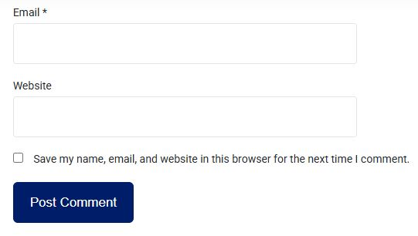

Outstanding questions:

For the postings on Q&A with Joe B, the comments will be directed to
Joe B: joebhed@verizon.net
Randy C: normeconomics@att.net

How do we (Joe B & Randy C) moderate the comments
coming into the Q&A postings?

