DEBT DRIVES WAR & WAR DRIVES DEBT:
The Powers of Bank Credit Creation in World War I
By Susan Peters
World War I: 1914-1918

Dear Reader,
If I were writing this paper one hundred years ago, I would have lived through the most destructive war, up to that time, in the history of mankind, called World War I.
“…the first three years of the war witnessed the largest military casualties in human history.” (1)
“The First World War was a catastrophe of such magnitude that, even today, the imagination has some difficulty grasping it. In the year 1916, in two battles (Verdun and the Somme) casualties of over 1,700,000 were suffered by both sides. In the artillery barrage which opened the French attack on Chemin des Dames in April 1917, 11,000,000 shells were fired on a 30-mile front in 10 days. Three months later, on an 11-mile front at Passchendaele, the British fired 4,250,000 shells costing 22,000,000 [pounds] in a preliminary barrage, and lost 400,000 men in the ensuring infantry assault…. On all fronts in the whole war almost 13,000,000 men in the various armed forces died from wounds and disease. It has been estimated by the Carnegie Endowment for International Pease that the war destroyed over $400,000,000,000 of property…” (2)
Carroll Quigley, in his massive work Tragedy and Hope, points to the primary importance of the new types of weapons and warfare that created this war:
“This emphasis on the offensive a outrance [attack to excess] by both sides led to a concentration of attention on three factors which were obsolete by 1914. These three were (a) cavalry, (b) the bayonet, and (c) the headlong infantry assault. These were obsolete in 1914 as the result of three technical innovations: (a) rapid-fire guns, especially machine guns; (b) barbed-wire entanglements, and (c) trench warfare.” (3)
Mankind had experienced war but never on this dimension. Today, to think about the four years of death and destruction can leave a person scared and incredulous. I was left speechless. Why would humans do this?
Carroll Quigley’s own words:
“To a people who believed in the innate goodness of man, in inevitable progress, in the community of interests, and in evil as merely the absence of good, the First World War, with its millions of persons dead and its billions of dollars wasted, was a blow so terrible as to be beyond human ability to comprehend.” (4)
The psychology and historical analysis and more, I have to leave to others. I wish to write about the PRIMARY importance of the American monetary system in this World War.

TABLE OF CONTENTS
THESIS OF PAPER 4
PREFACE 5

I Introduction to U.S. Money and the Bank Credit System 6

II 1913: Creation of the Federal Reserve System 21

III World War I (1914-17) – U.S. Is ‘Neutral’:
The Federal Reserve System and Gold 28

IV World War I (1917-18) – U.S. Enters War: 30
The Federal Reserve System and the Liberty Loans

V CONCLUDING THOUGHTS 34

THESIS OF PAPER

The U.S. monetary system is a bank credit system. By law, the commercial banks have been given the power to create the deposits in the borrowers account, when the loan is made. These created bank deposits become the means of exchange for goods and services.
Thus our means of exchange is debt. Our ‘money supply’ thus generates interest to the banks without stop, whether there is war or peace, whether there is prosperity or depression, whether the sun is shining or a hurricane threatens.
This is a profit-driven system. The system encourages greed in humans and is the mechanism for the private ‘money power’ to amass wealth for the few.
Since most profits are made from war, this system facilitates greatly the funding and execution of war. As Bob Potent, former Director of the American Monetary System (AMI) liked to say, “Debt Drives War, and War Drives Debt”.

“Every time a bank makes a loan, all they are doing is making an entry in their books for the amount of the loan.”
Stephen Zarlenga, founder of the American Monetary Institute (AMI)

PREFACE

Let me thank the American Monetary Institute (AMI) in Valatie, New York, for asking me to undertake this study of ‘Debt Drive War & War Drives Debt’. It’s an honor for me. It has also given me the opportunity to grow as a human being. Being someone who has never undertaken the focused investigation of historical facts and sources and their interpretation, this process gave me delight in discovery, consternation over hidden history, fear of the ponderous footsteps of historical force , but ultimately a great hope that I, as a human, can think creatively and with enjoyment about understanding our world today and bring this knowledge to the general population.
I also want to acknowledge and remember the former AMI Director, Bob Poteat, who passed away last year and in whose name this scholarship was offered me. I have the great opportunity to travel with Bob and Jamie Walton (the current AMI Director) in February of 2018 to Europe for three weeks. We attended an international monetary reform conference in Zurich, “Money Creation in the Modern Economy”, and also met with monetary reformers in Italy (Bologna, Rome), Amsterdam, and Iceland. Both Bob and Jamie were fun travelling companions. It’s was Bob’s first time ever in Europe. His career as an electrical engineer, managing the installation of elevators in skyscrapers, had taken him all around North and South America, but not across the Atlantic. One of Bob’s most entertaining stories (for me) was his description of being sent to a central American country (I forget which) to manage an installation, behind schedule due to personnel problems. In testing the elevator, Bob rode up to the top floor of the office building. When he got out, there was David Rockefeller, sitting behind a large desk with his feet up on the desk! Bob introduced himself and left. At the time, David Rockefeller was head of Chase Bank as well as probably many other powerful groups, all of which today’s monetary reformers would love to convince that only publicly-issued money will work for the world.
Bob enjoyed himself immensely.
The title of this scholarship paper is a title from Bob Poteat’s talks on monetary reform. He was a longtime member of Veterans for Peace and talked to this organization among others on this topic.

I
Introduction to U.S. Money and the Bank Credit System

The Difference Between Public Money and Private Bank Credit
Going back to the U.S. colonial period, I was shocked to find out that colonists would not allow private banks into the colonies. Starting in Massachusetts in 1690, and spreading to all the colonies by 1760, all 13 colonial legislatures decided to issue colonial paper money (‘script’) for use as money for goods and services. English coin was hard to find, siphoned off to England to pay for goods and taxes. The colonists, at times driven to barter or using commodities as money, learned as they experimented with their script: for example, some colonies created too much script and caused high prices. But, of great importance to understand: the colonies did not issue more paper script than their legislatures authorized.
It was a beautiful thing and brought them out of depression into prosperity.
“…there was a cry among the people for more paper money … I was on the side of an addition, being persuaded that the first small sum, struck in 1723, had done much good by increasing the trade, employment and number of inhabitants in the province, since I now saw all the old houses inhabited and many new ones building; whereas I remembered well … many of the houses … with bills on their doors, ‘to be let,’ … which made me think the inhabitants of the city … were deserting it.” Benjamin Franklin (5)
“Experience, more prevalent than all the logic in the World, has fully convinced us all, that it [paper money] has been, and is now of the greatest advantages to the country.” (6)
This ‘paper money’ was issued by the colonial government. It supplied a means of exchange, a necessity of every society. This means of exchange was an asset of the government, not of any private parties. The money benefited everyone, not the few.
After the Revolution, a new constitution, The Articles of Confederation, was written. The Articles gave power to the congress to “emit bills on the credit of the united states.” The colonists – now citizens of a new nation – recognized the importance of a publicly issued money. Indeed, this publicly issued money had not only brought prosperity to the colonies, but had carried the colonists through many years of war to win against the most powerful nation in the world, Great Britain.
However, at the birth of our nation, private banks entered, chartered by the new state legislatures and congress as corporations. These public charters gave the banks the privilege of issuing bank notes for loans. But, these private banks were banks of issue, not banks of deposit. This meant that they printed private banknotes and loaned them out, based on the bank’s assets, usually gold; but they loaned more than the value of their gold. This was the system prevalent in the European continent. This was private credit, to be used as ‘money’ by the people. This was debt - the bank notes entered circulation as a loan. This was for profit – the loan needed to be repaid with interest to the bank.

The spreading private banking system, creating its private credit, was profit-driven – every loan reaped more credit, known as interest, to the banker. The public money was for the common good, supporting the labor of people building a new nation and needing a fair and decent means of exchange to share the wealth created with their efforts.

The human emotion of GREED would be encouraged by putting the ‘money power’ – the power to create money and decide who gets it – into private hands. Today, this private credit system is known as ‘capitalism’, but the fact that today’s money supply is created by private banks is unknown to the population, whose schools do not include this knowledge and history.
The Public versus Private Struggle over the ‘Money Power’
At the end of the first decade of our new nation’s life, a Constitutional Convention wrote a new Constitution of the United States. During the Convention, a struggle took place over giving the Congress the explicit power to “emit bills on the credit of the united states”. Some delegates, understanding the nature of money and the importance of public control, wished this power to be explicated stated in the new constitution. Their proposal failed. Some delegates wished to explicitly forbid this power in the new constitution, but their proposal failed also. In the end the document is silent on this power, neither conferring or forbidding it. Instead, the following words were included to express the monetary power of the nation: “To coin Money, regulate the Value thereof, and of foreign Coin, and fix the Standard of Weights and Measures”. Back in 1787, ‘to coin Money’ included not only issuing gold and silver coins but it meant any form of public money. This ambiguity would be used by the banking system as support for their private creation of money.
December 14, 1790, Secretary of the Treasury, Alexander Hamilton submitted to Congress the Second Report on the Public Credit, calling for the establishment of a National Bank, chartered by Congress. In this report Hamilton describes how the private bank creates bank credit, used as ‘money’, using the bank’s accounting. There was no need of bank notes to create a loan. The ordinary citizen, including national leaders, did not understand that the bookkeeping entries were ‘money’; they used paper money and coins.

“Every loan, which a Bank makes is, in its first shape, a credit given to the borrower on its books, the amount of which it stands ready to pay, either in its own notes, or in gold or silver, at his option. But, in a great number of cases, no actual payment is made in either. The Borrower frequently, by a check or order, transfers his credit to some other person, to whom he has a payment to make; who, in his turn, is as often content with a similar credit, because he is satisfied, that he can, whenever he pleases, either convert it into cash, or pass it to some other hand, as an equivalent for it.

And in this manner the credit keeps circulating, performing in every stage the office of money, till it is extinguished by a discount [purchase*] with some person, who has a payment to make to the Bank, to an equal or greater amount. Thus large sums are lent and paid, frequently through a variety of hands, without the intervention of a single piece of coin.” (7)
* - added by this author

Reader, please note the meaning of this: ‘…extinguished by a discount [purchase] with some person, who has a payment to make to the Bank…’. Bank credit disappears off the books of the bank when the debt to the bank is paid. This is the nature of bank credit. The more bank loans, the more circulating credit. The more loans repaid to the bank, the less circulating credit. An unstable money supply is built on private credit.

In 1791, Hamilton wrote the following to President Washington for the definition of a bank:

“For the simplest and most precise idea of a bank is a deposit of coin or other property as a fund for circulating a credit [loan] upon it which is to answer the purpose of money.”(8)

The difference between money (issued by a sovereign government as an asset to the commonwealth) and bank credit (issued by a private bank when it makes a loan, therefore a debt) is not known in our world today. The nature of money has been kept hidden and confused.

Economic Growth in the 19th Century

The historian Bray Hammond describes the early decade of our new nation:

“When the Bank of England was a century old, in 1794, there were but four other chartered banks in the British Isles. There were then already eighteen chartered banks in America, only thirteen years after incorporation of the first American bank.”(9)

By 1830 there were over 300 state-chartered banks in the nation. Their bank paper (‘credit’) was accepted because, being chartered by the state government, the bank paper was accepted for payment to the government. In fact, in April 1816 Congress specifically authorized the Treasury’s acceptance of the notes of specie-paying state banks [banks redeeming bank notes with gold or silver]. This private system of credit brought with it much fraud, causing harm to people. But the need for a mean of exchange was tremendous. And the government was not supplying enough. As Bray Hammond described it:

“In the early 19th century the borrowers were the merchants, speculators, enterprisers, and promoters who were building up the modern American empire… the chronic and significant condition has been the prosperous use of borrowed funds by business men.”(10)

When the Civil War erupted, Lincoln and his advisors/supporter asked congress to authorize the issuance of Greenbacks – paper money as legal tender, issued without debt. True money, not credit. Congress agreed. The private banking interests, however, fought this public money. After the war, they tried to remove the Greenbacks from circulation. In this they were not successful, but they did manage to restrict the circulation to $347,000,000.

The need for funds to wage the Civil War by the North also brought the National Bank Act of 1864. According to this law, with $50,000 in capital, a bank could obtain a national charter as a routine matter, through the Treasury’s new office of the Controller of the Currency. National bank notes, under the law, would be issued by the private national banks, up to the amount of government bonds owned by the bank and lodged at the office of the Controller of the Currency in the Washington Treasury; the bonds were the security for the notes. In addition, national banks were required to maintain reserves proportional to their liabilities (bank deposits). This was the beginning of today’s ‘fractional reserve banking’; as Bray Hammond says:
“It embodied in the law what good bankers had always observed, voluntarily.” (11)
A tax was levied on state banknotes by the national government, to allow for only national banknotes in circulation. The state banks responded by stopping issuing banknotes, but continued to create bank deposits from loans and service deposits.

The issue of public versus private creation of money was a primary issue in every national election. The years between the Civil War and the end of the century saw the creation of many third parties, calling for the issuance of public Greenbacks by the Treasury in place of private banknotes. People wanted a public money, issued by their Treasury, without debt.

Investment Banking
In the 19th century, the vast wealth of the United States drove agricultural, commercial, and industrial growth throughout the century. Corporate organization was introduced into industries like railroads, mining, and utilities. British and other European investors purchased American stock and bond securities, which gave high investment returns. These foreign funds accelerated the industrialization.
Richard Corey points out, throughout the century, there were:
“…irresistible constructive forces… Industry and agriculture were transformed by more efficient machinery… A decisive aspect of this development was the increasing dependence of industry on finance…” (12)
“By 1856 foreign investors owned $203,000,000 out of an aggregate $1,407,000,000 of American national, state, city and corporate bonds and stocks.” (13)
“Railroad construction absorbed more foreign capital than all other industrial enterprises… The Morgans, singly and in combination, sold millions of railroad securities to foreign investors.” (14)
After the Civil War, in addition to these credit-making state and national banks, U.S. investment banks developed: private banks, selling stocks and bonds to American and foreign investors. Private banks are chartered by neither the state nor the national government; they operate as individual proprietorships or partnerships. But they thrive off of the bank credit system and the corporate stocks and bonds.
Unlike publicly-chartered commercial banks, private investment banks were not authorized to issue banknotes or accept deposits. Instead, they served as brokers or intermediaries, bringing together investors and the firms that needed their capital, i.e., selling corporate stocks and bonds. They sold ‘securities’ in railroads, manufacturing, mining, and utilities, among others. The first $1 million dollar stock turnover was in 1886. In 1889 the Wall Street Journal began publishing. And in 1896 the Dow Jones Industrial Average was begun.
The stock and bond trading siphoned the commercial bank credit from their customers’ accounts into the accounts of industrial and other corporate firms – and into the accounts of the investment bankers, who earned huge commissions and fees. In addition, the investment bankers, with their expertise, could easily manipulate the prices of securities and ‘skin the hide’ of the ordinary people, siphoning off their savings. The investment bankers were ‘farming other people’s money’ to make their huge profits, all with the help of the bank credit system and the securities markets.
This financial edifice was built on the commercial banking system. The national banks’ paper notes were legally backed by the Treasury. Their bank deposits were not. Bank deposits were simply promises-to-pay to the customer on demand the government coin and currency. Fear of failure of a bank would cause depositors to ‘run’ to the bank to withdraw their deposit in the government’s ‘lawful’ money - ‘real’ currency or coin. But many times there would not be enough in the bank. The bank would be bankrupt. Savings would be lost. People ruined.
There were major bank panics between the Civil War and World War I:
“…recurrent banking difficulties… most severe… 1873, 1884, 1890, and 1893 when bank failures, runs on banks, and widespread fears of further failures produced banking crises and, on several occasions, most notably 1893, suspension by most banks of convertibility of deposits into currency.” (15)
The Trusts
Beginning in the last decade of the century, the investment banks, helped by the credit of commercial banks in New York and other large commercial cities, worked to build communities of corporate firms, known as ‘cartels’ or ‘trusts’.
“…the years 1895-1904 witnessing the first big mergers and acquisition boom. The amalgamations were helped, and in some cases instigated, by Wall Street investment banks, particularly J.P. Morgan and Kuhn, Loeb, the leading houses.” (16)
“When McKinley took office… the middle class looked on impotently while factories, railroads, gas and electric plants, street railway lines, telephone systems and mines were converted from a state of individual or mere corporate ownership into the trust form, owned by great single corporations with stupendous amounts of capital….” (17)
“The great magnates controlled vastly powerful New York banks… The stock issues of the Steel Trust, as well as those of many other trusts, were sold to these banks.” (18)
This concentration of corporate control and wealth was built on the people’s own credit. In 1901 the U.S. Steel Trust was created, the creature of the J.P. Morgan firm. Morgan received stock for his efforts, which he sold to the public. Here is a description of that transaction:
“The stock obtained by him he was able to sell at a market price of about 50. By October, 1902, Morgan and his immediate partners in the syndicate had already distributed $40,000,000 in profits. From whom did these stockjobbing profits come? From a host of middle class investors throughout the world. Lured on by the glowing prospectuses of the Steel Trust, and certain that the money that they put in would produce large dividends, and the stock would rise in value, they literally scrambled to pay over their money for the stock… in 1904, it sank to 8 ¾. Hordes of middle class investors were ruined; the magnates had transferred their money to their own pockets.” (19)
The most well-known of the investment banking firms was J.P. Morgan and Company of New York:
“The power of J. P. Morgan and Co. was based initially on its ability to sell railroad stocks and bonds in the English and European markets. European investors placed $2.4 billion in the United States during 1880-1895, and owned a total of $4.5 billion in government and nongovernment bonds and shares in 1914.“ (20)

“The story of the House of Morgan is the story of the transformation of American capitalism… by the centralization of industry and finance.” (21)

Reader, please note. In this paper, J.P. Morgan and Co. will play a critical role in World War I. However, the centralization of industry and finance that occurs after 1890 in the United States, and up to the present day, was not the work of one man (however financially powerful). There were other powerful investment banks concentrating the credit and wealth into their hands; all competing with each other, but also needing to work together, most grudgingly, to make the economic and financial system work. And at the bottom of everything, was the private system of creating bank credit out of debt. The entire system generating profits for the banks and large corporate owners.
“At the dawn of the 20th century, some sixty ultra-rich families, through dynastic intermarriage and corporate, interconnected shareholdings, had gained control of American industry and banking institutions. (22)
“Great concentrations of wealth were being accumulated through macro usury – the structural misuse of society’s monetary mechanisms.” (23)
The ’Money Trust’ and the Pujo Committee
In 1912 the House Committee on Banking and Currency was authorized to ‘investigate the concentration of control of money and credit’. It was called the Pujo Committee, after its chairman, Congressman Arsene Pujo of Louisiana.
The committee did not find a money trust that would be unlawful under the Sherman Act, but they did find a dangerous concentration of money and credits in the hands of a few men of great power in the financial world.
They identified the agents of concentration:
“It is a fair deduction from the testimony that the most active agents in forwarding and bringing about the concentration of control of money and credit through one or another of the processes above described have been and are –
J.P. Morgan & Co.
First National Bank of New York.
National City Bank of New York.
Lee, Higginson & Co., of Boston and New York.
Kidder, Peabody & Co., of Boston and New York.
Kuhn, Loeb & Co.” (24)

The ‘processes’ mentioned by the committee included:
- Consolidating competitive or potentially competitive banks and trust companies
- Large stockholding in potentially competitive banks and trust companies
- Confederating these banks and trust companies by the system of interlocking directorates
- Using the influence which the more powerful banking houses, banks, and trust companies have secured in the management of insurance companies, railroads, producing and trading corporations, and public utility corporations. Influence includes stockholdings, voting trusts, fiscal agency contracts, representation upon their boards of directors, or through supplying the money requirements of railway, industrial, and public utilities corporations.
- Through partnership or joint account arrangements between a few of the leading banking houses, banks, and trust companies in the purchase of security issues of the great interstate corporations
The committee’s report included this detailed summary:
“The firm members and directors whose affiliations are thus shown number 180. In the aggregate they hold
- 385 directorships in 41 banks and trust companies having total resources of $3,832,000,000 and total deposits of $2,834,000,000;
- 50 directorships in 11 insurance companies having total assets of $2,646,000,000;
- 155 directorships in 31 railroad systems having a total capitalization of $12,193,000,000 and a total mileage of 163,200;
- 6 directorships in 2 express companies and 4 directorships in 1 steamship company with combined capital of $245,000,000 and gross income of $97,000,000;
- 98 directorships in 28 producing and trading corporations having a total capitalization of $3,583,000,000 and total gross annual earnings in excess of $1,145,000,000; and
- 48 directorships in 19 public utility corporations having a total capitalization of $2,826,000,000 and total gross annual earnings in excess of $428,000,000;
in all, 746 directorships in 134 corporations having total resources or capitalization of $25,325,000,000.” (25)

The committee report included some large diagram sketches of the relationships between banks and large corporations. Here are a few pictures from Exhibit No 243 – Feb. 25, 1913 entitled:
“Diagram Showing Affiliations of
- J.P. Morgan & Co.
- National City Bank
- First National Bank
- Guaranty Trust Co.
- Bankers Trust Co.
With Large Corporations of the United States” (26)

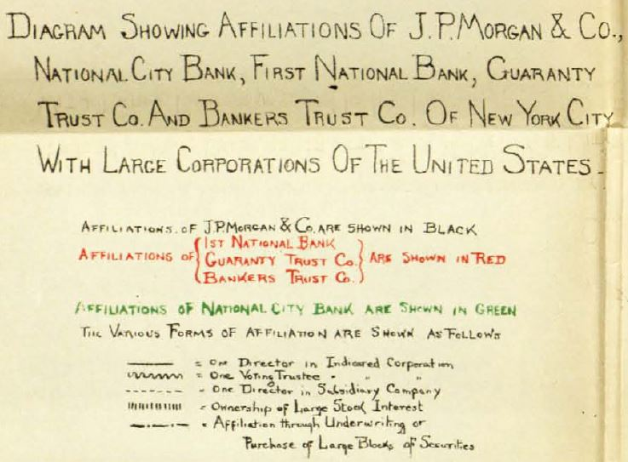
KEY TO DIAGRAM – Exhibit 243
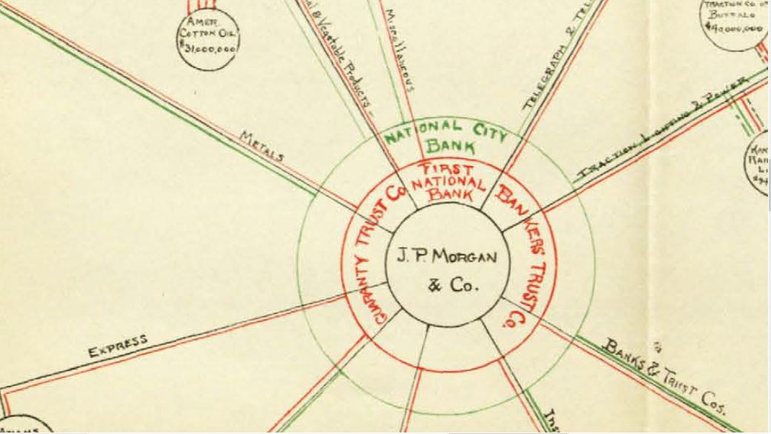
INSERT IN DIAGRAM – Exhibit No 243
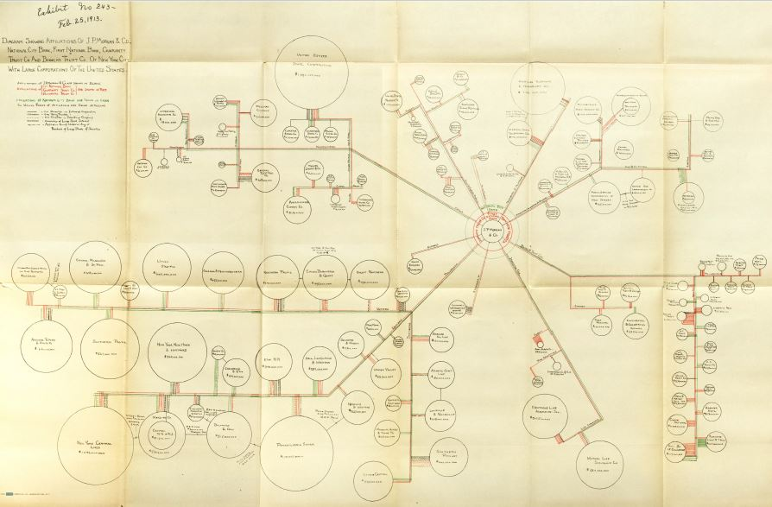
ENTIRE DIAGRAM, Exhibit No 243

Here is one more exhibit - Exhibit No 244 – Feb. 25, 1913 entitled:
“Diagram Showing Principal Affiliations of
    - J.P. Morgan & Co. of New York
    - Kidder, Peabody & Co. and Lee, Higginson & Co. of Boston
    - First National Bank, Illinois Trust & Savings, and Continental & Commercial Bank of Chicago” (27)

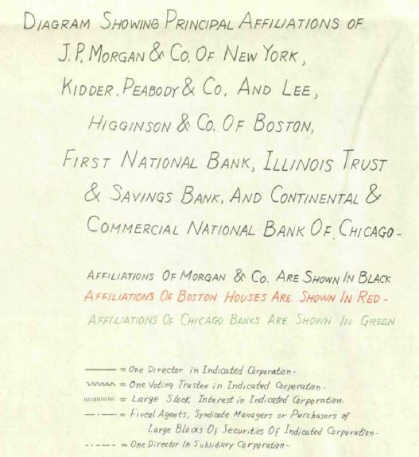
KEY TO DIAGRAM – Exhibit 244

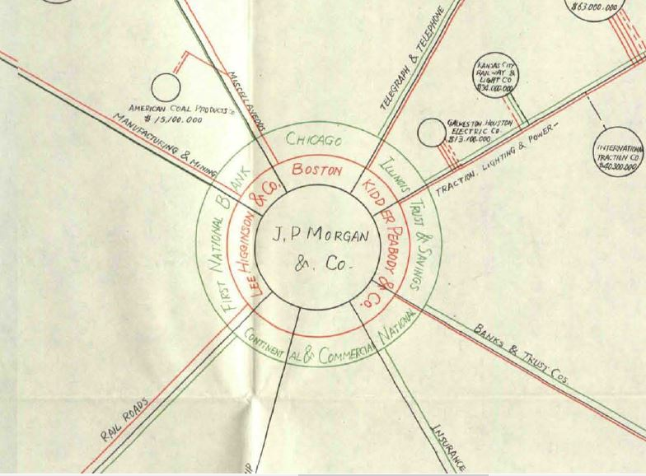

INSERT IN DIAGRAM – EXHIBIT 244

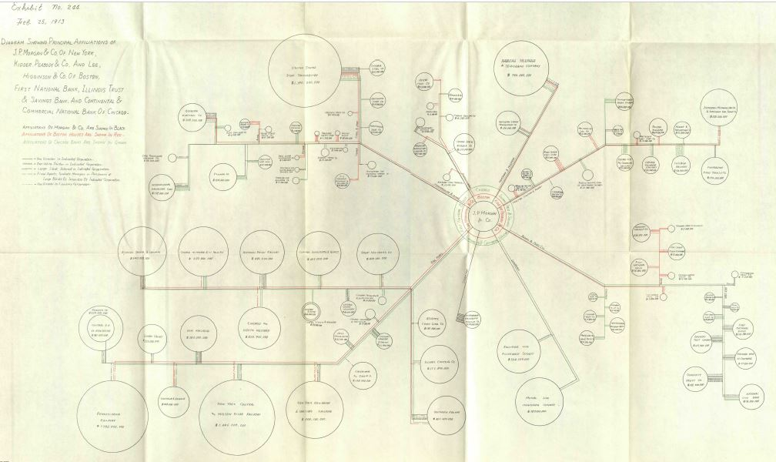
FULL DIAGRAM – EXHIBIT 244

II
1913: Creation of the Federal Reserve System

Intro
Since 1913, the Federal Reserve has become one of the most powerful financial institutions in the world, and the U.S. Dollar has become the world’s reserve currency. What was the nature of this institution created by the Federal Reserve Act and what powers was it given by the Congress?
The Creation of the Federal Reserve System was Controversial
Charles Lindbergh Sr., Representative from Minnesota, fought the creation of the Federal Reserve. He publicly identified the real problem: the government had given to private commercial banks the privilege of creating the nation’s means of exchange as debt. He described it succinctly : “The government have delegated to the rich the privilege of making the money and charging the rest of us for its use.” (28)
On the day the Federal Reserve Bill was signed by President Wilson, Lindbergh declared in Congress: "This Act establishes the most gigantic trust on Earth. When the President signs this bill, the invisible government by the Monetary Power will be legalized…" (29)
The public monies of the American colonies, of the Continental Congress, and of the Civil War Greenbacks were serving the true purpose of money – to facilitate exchange. Here is Lindbergh’s words:
“Money is the means of exchange among all people. Its regulation is absolutely a governmental function, and the Government has no natural inherent power that enables it to impart to money any other property or quality than that of making it the agent of exchange.” (30)
The passage of the Federal Reserve Bill was a long drawn-out battle both in and out of Congress. The power of the banks, and the power of the trusts that grew up around them, spawned much democratic unrest and organizing.
Ordinary people were suspicious of the financiers and big bankers. The ordinary person often lost lifetime savings with the failure of a bank. People wanted lawful money - the government’s gold coins, the Greenbacks, etc.
Government Issued Money: Legal Tender and Lawful Money
By 1913, the state and national governments had set minimum bank reserves for their banks of issue. The reserves were the government money, needed to be kept by the bank, for the conversion of deposits into “cash”.
Congress passed a Gold Standard Act on March 14, 1900, which became the foundation of the American payments system. This act “fixed gold as the [emphasis in the original] standard legal tender monetary metal.” (31) The dollar price of gold was set at $18.60 per ounce. The act began with this declaration:
“That the dollar … shall be the standard unit of value, and all forms of money issued or coined by the United States shall be maintained at a parity of value with this standard, and it shall be the duty of the secretary of the Treasury to maintain such parity.” (32)
Here is a list of the money issued by the U.S. Treasury, which would be kept equivalent in value to the gold dollar, the legal tender:
Gold certificates – paper money, redeemable in gold at the Treasury;
represented gold kept on deposit at the Treasury
Greenbacks (aka U.S. Notes) – paper money, redeemable in gold at the Treasury
Silver dollars – coins - also legal tender
Silver certificates – paper money, receivable for customs, taxes, and all public dues
represented silver kept on deposit at the Treasury
All of these Treasury coins and paper money were considered ‘lawful’ money, equivalent to the gold coins. People used them interchangeably.
There was one more paper currency that was not lawful money, but which circulated at par with lawful money: national bank notes. The public had confidence in this paper money since, by law, a national bank was limited in the amount of notes it could issue and had to back its notes with Treasury bonds of equal or greater value. “The limitation on issuance and the strong backing behind national bank notes left the public confident that the notes could always be exchanged for lawful money [Treasury coin and currency].” (33) “…national bank notes after [1873] circulated at parity with other currency”. (34)
Gold coins, lawful money, and national bank notes were all acceptable to the public. This was the money they trusted. This was their government’s money. The “real money”.
Growing Reform for a “Lender of Last Resort”
Throughout the 19th century, the instability of the private banking system caused a growing awareness of the need for change. The belief was that the instability was caused when the public’s demand for currency could not be met. Reformers began to talk about the need for a ‘lender of last resort’ to supply the currency that was needed at times of strong demand, such as at the end of the agricultural harvest when crops were sold, local suppliers paid, and farm hands given their season’s pay. The business interests of the country also supported this change.
The Act’s Fundamental Change: “to furnish an elastic currency”
POWER TO ISSUE AN ELASTIC CURRENCY: Government lawful money did not expand very much in response to business growth, but the other part of the money supply – the bank deposits could. The more bank loans, the more deposits.
The fundamental change made by the Federal Reserve Act was “to furnish an elastic currency”. The 12 Federal Reserve Banks were given the authority by Congress to issue Federal Reserve Notes, a government-backed currency, to their member commercial banks.
The Fed Notes would gradually replace the lawful currency in the hands of the public, which now could become part of the bank’s reserve. This made it possible for banks to make more loans (creating more deposits). The money supply could expand and contract with the needs of business.
POWER TO PURCHASE LOANS FROM MEMBER BANKS: The Fed Notes would be put into circulation by the new power of the Fed Banks top purchase (‘discount’) loans from their members and pay with Fed Notes. The bank loans were called ‘eligible paper‘ – bank ‘bills’ or ‘notes’ representing the legal loan contracts between member bank and borrower. The loans were short-term only (to be paid within 3 months). Their purpose was to fund commercial activity which enabled the country’s yearly production to be brought to market, like the purchase of finished goods for resale. The ‘discounted notes’ were known as “commercial paper”.
Here was the mechanism to ‘refund’ the commercial banks and issue Fed Notes into circulation as payment for their notes. A pyramid of debt could now grow.
But the Act also gave the Fed Banks authority to buy member bank loans secured by the bonds and notes of the Government of the United States. This became very significant for the U.S. government financing of World War I from 1917 to 1919. The government funded the war by selling Treasury bonds; most of which were bought either by people taking out a loan from a bank or by banks buying them directly from the Treasury. As Friedman and Schwartz noted:
“… World War I produced a correspondingly rapid growth of Federal Reserve money. By 1920, 69 per cent of high-powered money [member deposits at Fed Banks] consisted of Federal Reserve notes and
deposits.” (35)
The Federal Reserve System: Publicly or Privately Controlled?
Was the power to create a public means of exchange being handed over to private interests? Even today the public/private nature of the Federal Reserve System keeps the public confused.
FEDERAL RESERVE BOARD: The Act created a Federal Reserve Board in Washington D.C., composed of 7 members. Two of the members were ex officio: the Secretary of the Treasury and the Controller of the Currency. The other 5 members were appointed by the President of the United States with the consent of the Senate. At least two of the appointees were to be experienced in banking and finance.
The Board’s role was to set policy and oversee the Fed Banks: set the rate of interest for member banks borrowing from their Fed Bank, oversee issuance and redeeming of Fed Notes by Fed Banks, etc.
12 FEDERAL RESERVE BANKS: The country was divided into 12 geographical regions, each with a Fed Bank to contain the reserve accounts of its member banks and to perform the moving of funds between these accounts for the clearing of bank checks at the end of each day. Each Fed Bank was supervised by a board of directors composed of 9 members. Six members were chosen by the member banks; 3 appointed by the Board in Washington. Each member bank was required to buy stock in their Fed Bank, in proportion to the – there were no shares owned by the government.
The Fed Banks would be banks of issue and of deposit: issuing Fed Notes and accepting deposits from their member banks. The deposits would include reserve deposits of lawful money and national banknotes, deposits of Fed Notes, etc. They would have the power to buy member banks’ ‘bills’ (legal loan contracts made by member banks), paying with Fed Notes. They would have the power also to buy Treasury notes and bonds from the member banks.
FEDERAL ADVISORY COUNCIL: The Fed Council was appointed by the 12 Fed Bank boards of directors, one from each Fed Bank. The Fed Council was to meet with the Fed Board to advise it.
Given the composition of the Federal Reserve Board, the Fed Bank boards of directors, and the Fed Council, the influence of the private bankers was impressive. From Friedman and Schwartz:
“Able and persuasive men at the Reserve Banks exert influence by the weight their views carry in the decisions of the Board or the System as a whole, rather than directly through independent action by the Banks.” (36)
Wealthy businessman Irving T. Bush, wrote Paul M. Warburg (a banker and one of the important architects of the Federal Reserve Act), with his opinion of the new system, observing the compromises made by the Congress to pass the Act:
“In theory, the control of the Federal Reserve Board is general. In practice, the real banking operations of the country will be carried on under the direction of the officers and directors of the Federal Reserve Banks, and the Federal Reserve Board will only exercise control upon certain fundamental questions involving public welfare.” (37)
Here are the words of Marriner Eccles, Chairman of the Federal Reserve Board during the tenure of President Franklin Roosevelt:
“Over the years, practices had grown up inside the System which had reduced the reserve board in Washington to impotence. The System had originally been designed to represent a blend of private and public interests… Private interests, acting through the Reserve banks, had made the System an effective instrument by which private interests alone could be served.” (38)
Telling details from the Act:
- The salaries of the Board members were paid by assessments on the Fed Banks, not by the government.
- The expenses of the Fed Banks would be paid from the earnings of the Banks. The Federal Reserve System would not be dependent on the government for the funds to function.
The Federal Reserve Act: Federal Reserve Notes
What was the nature of the Federal Reserve Notes, planned by the Act to replace the national bank notes, the most numerous currency in circulation?
Section 16 of the Act says: “The said notes shall be obligations of the United States and shall be receivable by all national and member banks and Federal reserve banks and for all taxes, customs, and other public dues.” (39)
A government obligation is a debt that is backed by the full taxing power of the U.S. government, like Treasury bonds and notes. The Fed Note therefore is a government debt, issued as a means of exchange - in parallel to the power given to member banks to create loans as deposits, another means of exchange. The Federal Reserve System was a pyramid of debt.
Was this power, to issue Fed Notes (government debt) as a means of exchange, being handed over to a private System?
The Fed Banks needed to keep a gold reserve of 40% for redemption of the Fed Notes.

Section 16 says: “They shall be redeemed in gold on demand at the Treasury Department of the United States, in the city of Washington, District of Columbia, or in gold or lawful money at any Federal reserve bank… Federal reserve bank shall maintain reserves in gold or lawful money of not less than thirty-five per centum against its deposits and reserves in gold of not less than forty per centum against its Federal reserve notes in actual circulation… (40)

Every $1 Fed Note had to be backed by 40 cents of gold in the Fed Bank’s gold reserve. The more gold reserve, the more Fed Notes could be issued. A major goal of the System, from its inception, was to get the gold from the hands of the people and from member bank reserves into the Fed Banks.

Here is part of a letter, dated February 29, 1916, written by Paul Warburg, one of the major architects of the System and a member of the Federal Reserve Board from its opening in 1914 to 1918. Warburg was writing as a “personal and confidential expression of my views” to Representative Carter Glass, Chairman of the House Committee on Banking and Currency in 1913, who worked to get the Federal Reserve Act passed.

“All of which goes to show that there is too much gold carried in the pockets of the people and in the vaults of the banks, that there is not enough concentrated in the Federal Reserve Banks and that their lending power today is not sufficient to give us a feeling of reliance in the strength of the system. I shall not at this time make any exhaustive argument for vesting Federal Reserve notes with legal reserve qualities. As you know, I am profoundly convinced that sooner or later this step will have to be taken…” (41)

In addition to the 40% gold backing, 100% of the value of a Fed Note had to be backed by commercial paper in possession of the Fed Bank. A member needing currency would sell commercial paper (the legal loan contract) to his Fed Bank for Fed Notes. When the commercial paper matured, the Fed Bank would return it to the member and get refunded with the matured principal and interest due on the original loan. The difference between the lower price paid to the member by the Fed Bank and the matured funds recouped to the Fed was an interest charge for this service.

Here is the opening statement of the Federal Reserve Act. The creation of the Fed Notes were tied to the purchase of commercial paper:

“AN ACT
To provide for the establishment of Federal reserve banks, to furnish an elastic currency,
to afford means of rediscounting* commercial paper, to establish a more effective supervision of banking in the United States, and for other purposes.” (42)
* Bankers called the loans they made ‘discounts’. When they sell the ‘discount’ to their Fed Bank for Fed Notes, it was called ‘Rediscounting’.
The Federal Reserve Act: Member Bank Reserves
All national banks legally had to be members of the Federal Reserve System; state banks could join if they wished and met requirements. By law, all banks, inside or outside the System, had to keep “reserves”.
REMINDER WHY “RESERVES” WERE NECESSARY: The member banks were banks of issue: every time the bank made a loan, it created a deposit in the borrower’s account (debt as a means of exchange). The U.S. Treasury issued the government money as a means of exchange without debt. During bank runs, the bank deposits could disappear and with them the lifetime savings of people. So, the law mandated a bank reserve of government coin and lawful currency, so any customer could exchange his deposit for government money, which didn’t disappear.
REMINDER WHAT THE “MONEY” SUPPLY WAS: The “money supply” was a combination of the two – bank deposits (debt) and government money (an asset). As the economy grew and grew, more of the nation’s means of exchange were bank deposits. This meant more profits to the banks, receiving the loan’s interest until the loan was paid off.
The Federal Reserve Act set member reserve requirements: the percentage of bank deposits which would be backed by a reserve of government money. Member banks located in central reserve cities (New York, Chicago, St. Louis) had higher reserve requirements than other banks. For example, a member bank in New York needed to keep the value of 18% of their demand deposits in a reserve, while a country bank only 12%.
The Act made it mandatory that the bank reserves could be stored either as a deposit at the Fed Bank or in the bank’s vault. The member could no longer store their reserve as a deposit with another bank.
The Act set a minimum percentage of bank reserves that had to be kept on deposit at the Fed Bank and a minimum percentage that had to be kept in the bank vault. Beyond these minimums, the member could decide where to keep the rest of the reserve – on deposit at the Fed Bank or in its vault.
The thinking was that this accumulation of reserves with the Fed Banks and the new ‘elastic’ Fed Notes would protect all members from any bank runs or panics.
The Act thus resulted in a concentration of gold reserves in the Fed Banks. This concentration would allow the issuance of more Fed Notes, which needed to be backed by 40% gold at the Fed Bank. More Fed Notes would find their way into the hands of depositors, to replace that ‘confusing’ government money. Here are parts of an address by Paul Warburg, before a convention of bankers in September, 1916:
“At the time of the opening of the Federal Reserve Banks, Sir George Paish said to me, ‘The future of your system will depend upon your ability to get under the control of the Federal Reserve Banks the scattered gold of your country.’ “ (43) p 37
“These are conditions which, in the long run, may be the cause of heavy gold exports from the United States… If, on the other hand, we forearm, we may grasp the opportunity of taking our place as the strongest of the world’s bankers…” (44) p 14
“Ultimately we must rid our country of the confusing multiplicity of currency with which we are now afflicted… The circulating currency of the country ought to be silver certificates in the small denominations, and Federal Reserve notes. The best place for gold and gold certificates will be in the Federal Reserve Banks.” (45) pp. 28-29
“…a greenback and a Federal Reserve note are as different as day and night – the one issued as a perpetual currency… and the other issuable… expanding and contracting [with the needs of business]… and secured by a generous minimum reserve of gold…” (46) p. 38

III
World War I (1914-17) – U.S. Is ‘Neutral’ :
Federal Reserve System and Gold

Investment Banking firm of J.P. Morgan Hired by England and France

In the first week of August, 1914, the war began in Europe. On August 9, the firm of J.P. Morgan asked U.S. Secretary of State William Jennings Bryan if the U.S. government would object to loans being made with the belligerent nations. Bryan advised President Wilson not to support this policy:

“Washington, August 10, 1914
My Dear Mr. President:

First: Money is the worst of all contrabands because it commands everything else… I know of nothing that would do more to prevent war than an international agreement that neutral nations would not loan to belligerents. While such an agreement would be of great advantage, could we not by our example hasten the reaching of such an agreement? We are the one great nation which is not involved and our refusal to loan to any belligerent would naturally tend to hasten a conclusion of the war.” (47)

Wilson, however, eventually did decide to permit these loans.

On January 15, 1915, the firm of J.P. Morgan “signed a Commercial Agency Agreement with the British government by which it entered into a wide range of purchasing and contracting arrangements with American firms in behalf of the United Kingdom.” (48) In May, 1915, France did the same.

“Morgan served as intermediary for His Majesty’s Government in arranging purchases of munitions, arms, uniforms, chemicals, in short all that would be needed to wage a modern war in 1914. As Financial Agent for the British Government, J.P. Morgan & Co. not only organized the financing of war purchases and decided which companies would be the suppliers, but it also set the prices at which the equipment would be supplied. Not surprisingly, corporations directly in the Morgan and Rockefeller groups of companies were the prime beneficiaries of Morgan’s astute purchasing.” (49)

“In 1916 alone American industry, despite the nation’s official neutrality, exported a staggering $1,290,000,000 worth of war munitions to England and France. By the eve of America’s entry into the war, J.P. Morgan & Co. had organized the export of some $5 billion worth of war material to the English and French, and later Italian, governments, all bought on credit organized by J.P. Morgan & Co. Such an amount – equivalent to about $90 billion in contemporary dollar value – had never before been transacted by a private bank group.
It was enough to cause a major banking crisis should the loans default.” (50)

Effect on the Federal Reserve System

The new Federal Reserve System was ready to support this huge economic upheaval:

“We have used statistical data for June 1914 as reflecting conditions at the outset of the period and for March 1917, at the end. Over that interval of not quite three years [the period of U.S. neutrality], the stock of money rose by 46 per cent and wholesale prices by 65 per cent.” (51)

The increase in the stock of money (government money and bank deposits created by loan making) is reflected in the rise of member bank reserves held in the Fed Banks. As of December 31, 1914, member banks had a total reserve of $1,515,302,917. (52) By March 5, 1917, the entrance of the U.S. into the war, the reserves stood at $2,641,921,000. (53) The excess reserves (reserves above the legal requirement) were $548,940,735 (54) on December 31, 1914 and rose to $1,109,065,000 by March 5, 1917. (55)

How the Allies Paid for U.S. Exported Military Supplies

SENDING GOLD FROM EUROPE: The increase of the member banks reserves reflected the huge flow of gold from Europe. During the period of U.S. neutrality, the belligerent nations shipped more than $1 billion in gold to the U.S. to pay for the exported military supplies. (56) Much of this gold found its way into the Federal Reserve member banks and became the basis of the increase in reserves and loans.

SELLING THEIR CITIZENS’ U.S. STOCKS AND BONDS: In addition, to also pay for the exported military supplies during this same period, the belligerent nations sold, for dollars in this country, $1.4 billion worth of American stocks and bonds owned by their citizens “and transferred under compulsion to government control…” (57) J.P. Morgan and Company would have been responsible for selling these securities on the U.S. stock and bond exchanges and making hefty fees and commissions.

BORROWING FROM U.S. INVESTORS: Finally, the belligerent nations borrowed about $2.4 billion from the financial markets (the bond markets). (58) J.P. Morgan and Company would also have been responsible for selling these bonds to the U.S. investors and charging his clients as much as they could bear. The Allies, his clients, however, were not in a good bargaining position.

The Allies raised “a total of no less than $5.3 billion” (59) through these various devices.

The U.S. Becomes a Creditor Nation: Gold and the Federal Reserve

On December 4, 1916, the Honorable William G. McAdoo, Secretary of the Treasury, reported to the nation that the U.S. stock of gold was the largest ever in our history, and indeed ever in the history of any nation:

“During the past year the prosperity which set in so strongly during the fiscal year 1915 has grown in strength and volume and is now widely diffused throughout the United States… The financial strength of the United States – the greatest in our history – gives us a commanding position in world finance. We have been transformed from a debtor into a creditor nation. On November 1, 1916, the stock of gold coin and bullion in the United States was estimated at $2,700,136.976, an increase of $714,597,804 in the past 16 months. This is the largest stock of gold ever held in the United States or in any other country of the world.” (60)

“Through the operations of the Federal Reserve System and with our abundant supply of gold as a basis… we have been able to finance our great domestic and foreign trade without strain and to extend vast amounts of credit to other nations throughout the world… The experience of the past two years has brought into strong relief the value of the Federal Reserve System. It is not too much to say that our great prosperity could not exist without it.” (61)

Dear reader, let me remind you that the Federal Reserve System is an edifice of debt. On one level, the private commercial banks create deposits, all as loans to borrowers. On the other level, the private Federal Reserve Banks create Fed Notes, debts of the U.S. government. This is a bank debt system, not a government money system. And this bank debt system is being used to fund a world war.

IV
World War I (1917-18) – U.S. Enters War:
The Federal Reserve System and the Liberty Loans

Debt Drives War: The U.S. Declares War

By the beginning of 1917, the Allies were desperate for more loans from U.S. bankers and investors. Morgan had extended himself excessively, however, with his own funds direct to the Allies, in addition to selling foreign bonds on the U.S. markets. The British historian, Burton J. Hendrick, comments:

“The British were practically dependent for their existence upon the food brought from the United States, just as the Allied armies were largely dependent upon the steel which came from the great industrial plants of this country. If Great Britain could not find the money with which to purchase these supplies, it is quite apparent that they could not be shipped. The collapse of British credit therefore would have... led to a British surrender, just as effectively as would the success of the German submarine campaign.” (62)

In addition, the Russian Czar Nicholas II was dealing with a country increasingly falling apart. This situation made the eastern front against Germany insecure. In February, 1917, riots broke out in Petrograd with shouts of “Down with the war! Down with the Tsar!” (63) If the Russian Empire pulled out of the war, there would be no second front against the Germans. The entire German force would face the Allies on the western front. Allied surrender would be the result.

The U.S. Ambassador to Great Britain, Walter H. Page, was a dyed-in-the-wool lover of the British. He increasingly heard the desperate words from his equals in the British Foreign Office. On March 5, 1917, he wrote President Wilson:

“The inquiries which I have made here about financial conditions disclose an international situation which is most alarming to the financial and industrial outlook of the United States… Great Britain and France must have a credit in the United States which will be large enough to prevent the collapse of world trade and the whole financial structure of Europe…

If the United States declare war against Germany, the greatest help we could give Great Britain and its Allies would be such a credit… A great advantage would be that all the money would be kept in the United States. We could keep on with our trade and increase it, till the war ends… We should thus reap the profit of an uninterrupted and perhaps an enlarging trade over a number of years…
Of course, we cannot extend such a credit unless we go to war with Germany…
The pressure of this approaching crisis, I am certain, has gone beyond the ability of the Morgan financial agency for the British and French governments. The financial necessities of the Allies are too great and urgent for any private agency to handle…
There is now an uncertainty about our being drawn into the war… In the meantime a collapse may come.
(Signed) PAGE.” (64)

On April 2, 1917, President Woodrow Wilson went to Congress and asked for a declaration of war against Germany, saying, “The world must be made safe for democracy.”

War Drives Debt: The Liberty Loans

Marriner Eccles, Chairman of the Federal Reserve Board under President Franklin Roosevelt, wrote:

“…while the public debt at the time of the Reserve System was created stood at less than $1 billion, when the war ended, the debt was about $27 billion.” (65)

The U.S. Treasury offered five war loans to the U.S. public from April, 1917 to April, 1919. Four were called ‘Liberty Bonds’ and the fifth, offered after the armistice in November, 1918, was called a ‘Victory Liberty Bond’.

Liberty Loans Date offered Amount Bought (‘Allotted’)

First Apr 24, 1917 2,000,000,000
Second Oct 1, 1917 3,808,800,000
Third Apr 5, 1918 4,176,500,000
Fourth Sep 28, 1918 6,964,500,000
Fifth Apr 21, 1919 4,498,300,000
*TOTAL* 21,448,100,000 (66)
The U.S. Treasury wished to sell the bonds to the public, using their savings. In this way, inflation would be avoided. The public would simply transfer their bank deposits into the account of the Treasury. But Secretary of the Treasury William McAdoo was fearful that not enough bonds could be sold to the public to meet the incredible needs of the war.
“In order to ensure the full sale of each bond issue, his intention of carrying the campaign directly to the public was changed in practice to greater reliance on bank borrowing, both direct and indirect, inadvertently causing an expansion rather than a diversion of the money supply.” (67)
The Federal Reserve System Is Amended
Several amendments were made to the Federal Reserve Law to allow it to create the massive credit expansion necessary to fund the war.
“The Federal Reserve System, committed to the support of the Treasury… with the aid of several amendments to the Federal Research Act created the credit expansion potential by means of which the banking system played a major role in financing both the Treasury’s operations and the business expansion which took place at the same time.” (68)

Amendment of September 7, 1916
Dear reader, I want to stop here to explain one other privilege of the commercial banks. Just as the commercial bank can create deposits when they make a loan, they can also create deposits when they buy a security. The new deposit can come from either – making a loan or buying a security – and both result in an increase in the money supply.
The original Federal Reserve Act did not permit the Fed Banks to make direct advances or loans to member banks but permitted them to only “rediscount eligible paper” – buy members’ commercial loans to issue new Fed Notes.
With the amendment of September 7, 1916, the Fed Banks were allowed to make direct loans for fifteen days to members, with either commercial loans or government debt serving as collateral. This encouraged the member banks to create deposits and buy the Liberty Bonds. It also encouraged the member banks to create deposits for customers to buy Liberty Bonds. The money supply would expand enormously. In addition, with either the Liberty Bonds or loans for the Liberty Bonds, the bank could borrow Fed Notes from its Feb Bank. The 12 private Fed Banks would issue into circulation more of their currency, and take the place of the government lawful money.
“Once the United States entered the war, loans on government securities began to rival commercial paper as collateral…” (69)
Amendment of June 21, 1917
This amendment did two extremely important changes to the System.
REDUCE RESERVE REQUIREMENTS: First, the reserve requirements of the member banks were reduced. Remember, the legal reserve requirement was the proportion of its deposits that a member was required to maintain as ‘cash’ - gold or government lawful money. On demand, the customer could exchange his deposit for ‘cash’.
Banks in New York, Chicago, or St. Louis would now had to keep only 13% or a reserve (instead of 18%). Banks in smaller cities had their reserve reduced from 15% to 10%. Country banks, outside the cities, went from 12% to 7%. The result of this change was to permit the banks to create more deposits and lend them, to buy government bonds! The money supply would expand. The government would have more funds to fight the war. The banks would make a windfall of profit from interest! And, the government would be more and more in debt.
ALL BANK RESERVES HAD TO BE DEPOSITED AT THE FED BANKS. The original Federal Reserve Act allowed the member banks to keep some part of their reserves outside their Fed Bank - in their own vault or on deposit at another member bank. This was now changed. All reserves had to be kept on deposit at the Fed Banks.
Given the rapid increase in gold reserves – coming over from the Allies to buy war supplies - this gold could now be concentrated in the Fed Banks. This concentration would permit the issuance of more Fed Notes, since each Fed Note required a 40% gold reserve be kept at the Fed Bank. The result - more private Fed Note currency could be issued to replace the government money in the hands of the people.
The result of these two significant changes to the System was the following: between June 20, 1917 and December 31, 1917, the following was recorded by the Federal Reserve Board (70):
- Reserves with Fed Banks increased 73.6%:
from $ 862,000,000
to $ 1,497,000,000

- Investments in government securities increased 65.1%:
from $ 1,065,000,000
to $ 1,759,000,000

- Loans increased 31.4%:
from $ 9,370,000,000
to $ 12,316,000,000

The Increased Powers of the Federal Reserve System

These amendments created a more formidable power in the System.
Beware! The original Federal Reserve Law was ‘tweaked’ here and there, and suddenly the U.S. Government was $27 billion in debt!
To give private corporations the power to create the means of payment is to slowly, over time, give up control of our nation.
“…the total wartime expenditure of the United States government from April 6, 1917, October 31, 1919, when the last contingent of troops returned from Europe, was $35,413,000,000. Net corporation profits for the period January 1, 1916, to July, 1921, when wartime industrial activity was finally liquidated, were $38,000,000,000. More than two-thirds of … profits were taken by … those enterprises which the [1912-13] Pujo Committee had found to be under the control of the ‘Money Trust.’ “ (71)

V
CONCLUDING THOUGHTS

Origin of the Bank Credit System

The horror and pain of World War I continued for four long and terrible years, for those directly involved with the fighting and their relatives and friends. Millions of people were killed. Millions of people maimed. A generation slaughtered and traumatized.

The bank credit system, where commercial banks create deposits or issue banknotes when they make a loan, with profit to the bank, was the structure of the U.S. monetary system for over a hundred years leading up to World War I. But this system was a European creation. It was found on both sides of the Atlantic in 1914. The first government-chartered bank of issue was the private Bank of England in 1694. It also made loans by creating deposits or issuing banknotes.

This was the beginning of taking the power to create the nation’s means of payment away from the government, the only place where this mighty power can be kept under public control. The more public, the better.

This was the beginning of charging interest (usury) on the nation’s means of payment.

Let all nations teach their people the difference between government issued money without debt and private bank credit with debt.

Seeds of the Future

Dear Reader, while I was researching this paper, I had originally thought to also add a section on the period from 1944 to 1950. In 1944 the Bretton Woods international monetary agreement was signed. This agreement had made the U.S. dollar the world’s reserve currency alongside gold. I searched for how this had happened. The author of the agreement was a U.S. Treasury official called Harry Dexter White, who worked closely under Henry Morgenthau, the Treasury Secretary. But who was influencing Harry Dexter White?

One of the sources I found researching this paper was an article written by David C. Wheelock of the Federal Reserve Bank of St. Louis in November, 2013, “The Fed’s Formative Years: 1913-1929”. In this article, I found the following:

“War [World War I] disrupted European financial markets and reduced the supply of trade credit [loans] offered by European banks, providing US banks with an opening. Low US interest rates, abundant reserves, and new authority to issue trade acceptances [create loan deposits export and import activities] enabled American banks to finance a growing share of world trade. By the second half of the 1920s, over half of US imports and exports were financed by dollar-denominated acceptances, as was a large share of the international trade of other countries (Eichengreen 2011, p.30). The strength of the US economy and the greater use of the dollar for making international payments made the dollar the world’s leading reserve currency; by the mid-1920s, foreign governments and central banks held more of their foreign-exchange reserves in dollars than in any other currency (Eichengreen 2011, p.32).” (72)

Here was the source of the U.S. Dollar as today’s world’s reserve currency. And it was a couple of ‘tweaks’ of the Federal Reserve Law back in World War I. Watch those tweaks!

THE NEED ACT, HR2990

I am hoping that this paper can explain to people why this system must be abolished, for the sake of mankind on our planet. During most of our history, government controlled the power to create the means of exchange as an asset, without interest. It worked much much better than this bank credit slavery.

Please visit the website of the American Monetary Institute (AMI): monetary.org. This organization worked with Representative Dennis Kucinich for several years to prepare a monetary reform bill for Congress. This bill, the NEED Act (National Emergency Employment Defense Act, HR2990), was introduced into Congress two years in a row. It would, with very little disruption to the current society, change the bank credit system back into a government money system.

I thank the American Monetary Institute for giving me the opportunity to prepare this research for them. It is an honor, and I am grateful for how much I have learned about our monetary system by doing this work.

Sincerely,

Susan M. Peters
New York, New York
nychollis@use.startmail.com

