DEBT DRIVES WAR
AND
WAR DRIVES DEBT

The Powers of Bank Credit Creation during World War I

By Susan Peters

15th Annual Conference of the
American Monetary Institute (AMI)
Chicago, Illinois

October 3−6, 2019

PREFACE
World War I: 1914-1918

If I were writing this paper one hundred years ago, I would have lived through the most destructive war, up to that time, in the history of mankind. According to the American historian Carroll Quigley, “the first three years of the war witnessed the largest military casualties in human history.”(1) He further observes that
The First World War was a catastrophe of such magnitude that, even today, the imagination has some difficulty grasping it. In the year 1916, in two battles (Verdun and the Somme) casualties of over 1,700,000 were suffered by both sides. In the artillery barrage which opened the French attack on Chemin des Dames in April 1917, 11,000,000 shells were fired on a 30-mile front in 10 days. Three months later, on an 11-mile front at Passchendaele, the British fired 4,250,000 shells costing £22,000,000 in a preliminary barrage, and lost 400,000 men in the ensuring infantry assault…. On all fronts in the whole war almost 13,000,000 men in the various armed forces died from wounds and disease. It has been estimated by the Carnegie Endowment for International Peace that the war destroyed over $400,000,000,000 of property…(2)
Quigley, in his massive work Tragedy and Hope, points to the primary importance of the new types of weapons and warfare that created this war:
This emphasis on the offensive à outrance [attack to excess] by both sides led to a concentration of attention on three factors which were obsolete by 1914. These three were (a) cavalry, (b) the bayonet, and (c) the headlong infantry assault. These were obsolete in 1914 as the result of three technical innovations: (a) rapid-fire guns, especially machine guns; (b) barbed-wire entanglements, and (c) trench warfare.(3)
Mankind had experienced war but never on this scale. Today, to think about the four years of death and destruction can leave a person scared and incredulous. I was left speechless. Why would humans do this?
Quigley summarizes well this sentiment:
To a people who believed in the innate goodness of man, in inevitable progress, in the community of interests, and in evil as merely the absence of good, the First World War, with its millions of persons dead and its billions of dollars wasted, was a blow so terrible as to be beyond human ability to comprehend.(4)
The psychological and historical analysis of this tragedy, I will leave to others. What I wish to examine is the primary importance of the American monetary system in this war.

TABLE OF CONTENTS
Preface 2
Thesis 4
Acknowledgements 5

I U.S. Money and the Bank Credit System 6

II 1913: Creation of the Federal Reserve System 22

III World War I (1914-17)─The United States Is “Neutral”:
The Federal Reserve System and Gold 28

IV World War I (1917-18)─U.S. Enters the War: 31
The Federal Reserve System and the Liberty Loans

V Concluding Thoughts 35

THESIS

The thesis of this paper is that the use of private bank credit as a society’s money is detrimental to the life of all citizens, concentrates wealth and power into national institutions outside public control, and is a major driver of imperialism and war.
This will be shown by first examining the positive benefits of the country’s experience with government-issued money, and its contribution to equality and democracy.
Next, the bank credit system will be examined for its effect on the U.S. experience in World War I. The paper will study the Federal Reserve bill passed by Congress in December 1913 and implemented in November 1914; its effects on the U.S. economy during the period of U.S. neutrality (1914-1917); its influence on the United States’ entrance into World War I in April 1917; and finally the financing of the U.S. as a combatant in the war from 1917 to 1919.
Today, the U.S. monetary system is based on bank credit. By law, the commercial banks have been given the power to create the deposits in the borrower’s account when a loan is made. These bank deposits then become the means of exchange for goods and services─that is, they become what we use as money.
Why has the government’s most important responsibility and power to create our nation’s money supply been turned over to private corporations─commercial banks─for their profit? Under this system, our means of exchange is debt. Our money supply thus generates interest paid to the banks without stop, whether there is war or peace, whether there is prosperity or depression, whether the sun is shining or a hurricane threatens.
This profit-driven system encourages greed in humans and is the mechanism for the private money power to amass wealth for the few.
As the late Bob Poteat, former Director of the American Monetary Institute (AMI), liked to say, “Debt drives war, and war drives debt.” That insight was the jumping-off point of this paper.

“Every loan, which a Bank makes is, in its first shape, a credit given to the borrower on its books.” ─Alexander Hamilton,
First Secretary of the Treasury 1789─1795

“Every time a bank makes a loan, all it is doing is simply making an entry in the borrower’s account for the amount of the loan.” ─Stephen Zarlenga,
founder of the American Monetary Institute (AMI)
ACKNOWLEDGEMENTS

I wish to thank the American Monetary Institute (AMI) in Valatie, New York, for asking me to undertake this study of the proposition that “debt drives war and war drives debt.“ It’s an honor for me. It has also given me the opportunity to grow as a human being. Being someone who has never undertaken the focused investigation of historical facts and sources and their interpretation, this process gave me delight in discovery, consternation over hidden history, fear of the ponderous footsteps of historical force, but ultimately a great hope that I, as a human, can think creatively and with enjoyment about understanding our world today and bring this knowledge to the general population.
I also want to acknowledge and remember the late Bob Poteat, AMI Director (2017-2018), who passed away last year and in whose name this scholarship was offered to me. I had the great opportunity to travel with Bob and Jamie Walton (the current AMI Director) in February of 2018 to Europe for three weeks. We attended an international monetary reform conference in Zurich, “Money Creation in the Modern Economy,” and also met with monetary reformers in Italy, the Netherlands, and Iceland. Both Bob and Jamie were fun travelling companions.
It was Bob’s first time ever in Europe, and he enjoyed himself immensely. His career as an electrical engineer, managing the installation of elevators in skyscrapers, had taken him all around North and South America, but not across the Atlantic. One of Bob’s most entertaining stories (for me) was his description of being sent to a Central American country to manage an installation, behind schedule due to personnel problems. In testing the elevator, Bob rode up to the top floor of the office building. When he got out, there was David Rockefeller, sitting behind a large desk with his feet up on the desk! Bob introduced himself and went back down in the elevator. At the time, David Rockefeller was head of Chase Bank as well as probably many other powerful groups, all of which today’s monetary reformers would love to convince that only publicly issued money will work for the world.
The title of this scholarship paper is a title of one of Bob Poteat’s talks on monetary reform. He was a longtime member of Veterans for Peace and spoke to this organization among others on this topic.

I
U.S. Money and the Bank Credit System
Today, Americans are very wary of banks. The worldwide financial crisis of 2008 shook up the middle class, many of whom lost homes, retirement savings, and jobs. Since then, wealth inequality has skyrocketed. We can study the immediate cause of this debacle but it is more helpful to learn the history of our monetary system. When we understand this history, we can think more clearly about the changes needed to stop these crises and stop the amassing of great financial power in very few hands.
Government-Issued Money: An Asset
When I began to study the history of U.S. money, I was shocked to discover that all thirteen British colonies in North America would not allow private banks into their territory! How could that be? Today they are found on every corner of our commercial cities and in our shopping malls. Weren’t they always here? The answer is no.
The colonists, coming from the poverty and hunger of Europe, did not trust private banks. Starting in Massachusetts in 1690, and spreading to all the colonies by 1760, colonial legislatures decided to issue paper money (“scrip”) as the means of exchange. The colonial scrip was necessary because English coin was hard to find, siphoned off to England to pay for goods and taxes.
Generally the legislature spent the scrip into circulation, for colonial expenses. It circulated from hand to hand, encouraging work and trade. If too much scrip was issued, prices would rise, but the legislature learned to reduce the amount of circulating scrip─and thus reduce prices of goods and services─by accepting it for colonial taxes or by recalling it and giving English coin in return.
But─of great importance to understand─the colonies did not issue more paper money than their legislatures authorized.
The government-issued money was a beautiful thing and brought prosperity. Consider the words of Benjamin Franklin:
…there was a cry among the people for more paper money…I was on the side of an addition, being persuaded that the first small sum, struck in 1723, had done much good by increasing the trade, employment and number of inhabitants in the province, since I now saw all the old houses inhabited and many new ones building; whereas I remembered well…many of the houses…with bills on their doors, “to be let,”…which made me think the inhabitants of the city…were deserting it.(5)
Experience, more prevalent than all the logic in the World, has fully convinced us all, that it [government-issued paper money] has been, and is now of the greatest advantages to the country.(6)
This means of exchange was an asset of the government, not of any private parties. The money benefited everyone, not the few.
Not only did government-issued money bring prosperity to the colonies, but, during the Revolution, the Continental Congress issued paper money called “Continentals.” The Continentals carried the new country through many years of war, to defeat the most powerful nation in the world, even though Britain practiced economic warfare by printing and distributing millions of counterfeit Continentals to destroy their value.
Our first constitution, the Articles of Confederation, gave power to Congress to create a national “scrip.” The new country recognized the importance of government-issued money.
Private Banks: Debt, not Money
After the Revolution, the new state legislatures began to grant corporate charters to private banks! This was a great change. The corporate charter gave the bank the legal power to print their own paper “banknotes” as well as to create account entries, called “bank deposits.” The banknotes were loaned out to borrowers, when they signed a loan contract. Alternately, the borrower could choose to take the loan in the form of account credit. In this case, the bank would create the account entry when the borrower signed the loan contract.
The “banknotes” circulated in the local economy hand to hand. The bank deposits were circulated by the borrower writing a check on his account, just as we do today.
The charter gave the bank the right to lend their banknotes out to borrowers. The banknotes were therefore debt or “bank credit.” The borrower had to repay the loan with interest to the bank.
The charter gave the bank the right to create account deposits when making a loan to a borrower. The account entries were therefore debt or “bank credit.”
The circulating banknotes and checks could be returned to the bank at any time and exchanged for gold and silver coin from the bank’s vault. This was the government-issued money backing the banknotes and bank deposits. This was the real money.
This is the genesis of the system we have today. Today, private commercial banks no longer issue their own banknotes. But today our money supply is created whenever a private commercial bank makes a loan and creates the deposit in the borrower’s bank account. When I go into JPMorgan Chase and sign a mortgage, I am paying for that house with bank credit created by JPMorgan Chase. The mortgage funds are not taken from another’s account and “lent” to me; the bank is creating the funds by creating the deposit in my mortgage account. Today we use “bank credit.” Our money supply is earning interest for the private banks all the time. And this is legal!
The commerce of the country grew. With it grew the number of state-chartered private banks and the amount of “bank credit,” alongside government-issued money. By 1811 the number of banks increased to 88, and then by 1815 to 208! The human emotion of greed would be encouraged by putting the “money power”─the power to create the means of exchange and decide who gets it─into private hands.
The Struggle over the “Money Power”: Public versus Private
In 1787, a Constitutional Convention met to write a new U.S. Constitution. During the Convention, a struggle took place over the money creation power. Some delegates understood the importance of public issuance and wanted the power to be explicitly given to Congress─”to emit bills of credit” (paper “scrip”). Their proposal failed. Some delegates, supporting private issuance, wished to explicitly forbid this power to the government, but their proposal failed also. In the end, the Constitution neither confers nor forbids it.
Instead, the following words were included to express the monetary power of the nation: “To coin Money, regulate the Value thereof, and of foreign Coin, and fix the Standard of Weights and Measures.” Back in 1787, “to coin Money” included not only issuing gold and silver coins but also paper money. This ambiguity would be used by the banks to argue against the government issuing paper money and for their own private creation of banknotes, to be lent for the bank’s profit. The national government would be hesitant to issue its own paper money.
On December 14, 1790, Secretary of the Treasury Alexander Hamilton submitted to Congress the Second Report on the Public Credit. In this report Hamilton describes how private bank credit consists of accounting entries, which are transferred by check between people. There was no need of either the banks’ paper currency or the government’s coins.
He explained that the bank creates the credit in the borrower’s account when it makes a loan. This is the nature of all commercial banks, then and today:
Every loan, which a Bank makes is, in its first shape, a credit given to the borrower on its books, the amount of which it stands ready to pay, either in its own notes, or in gold or silver, at his option. But, in a great number of cases, no actual payment is made in either. The Borrower frequently, by a check or order, transfers his credit to some other person, to whom he has a payment to make…
And in this manner the credit keeps circulating, performing in every stage the office of money, till it is extinguished…with some person, who has a payment to make to the bank… Thus large sums are lent and paid, frequently through a variety of hands, without the intervention of a single piece of coin.(7)
Reader, please note the meaning of “…extinguished…with some person, who has a payment to make to the bank.” The “person” is someone who has borrowed from the bank. When the borrower repays the loan, the credit is “extinguished” or erased from the books of the bank!
This is the nature of bank credit. The more bank loans made, the more circulating bank credit. The more loans repaid, the less circulating credit. In other words, the bank loan system creates an unstable money supply. This has been the major cause of financial crises in our history, including the 2008 financial crisis through which we are still living.
In 1791, Hamilton wrote the following to President Washington for the definition of a bank:
For the simplest and most precise idea of a bank is a deposit of coin or other property as a fund for circulating a credit [loan] upon it which is to answer the purpose of money.(8)
There is a vast difference between money issued by a sovereign government and bank credit issued by a bank. The government’s money is an asset to the country. It is a means of exchange, which circulates and does not disappear. The bank’s credit is a debt to the borrower and a source of profit to the banks. It is a means of exchange, which is only created as a debt, which generates interest to the bank, and always disappears when the loan is repaid. Disappears!
The government spends the money on expenses for the general welfare, which circulates and supports a stable money supply. The bank issues the bank credit for its profit and as a debt, which disappears as the loan is repaid and creates an unstable money supply.
Today, the public is led to believe our government creates our money, but that is not true. Today, our money supply is bank credit. The nature of our money is hidden from the public.
Economic Growth in the 19th Century and the Growth of Bank Credit
The historian Bray Hammond describes the early decade of our new nation:

When the Bank of England was a century old, in 1794, there were but four other chartered banks in the British Isles. There were then already eighteen chartered banks in America, only thirteen years after incorporation of the first American bank.(9)

Starting at the beginning of our country, the need for a means of exchange was great: the production of wealth and its commercial exchange was ever increasing. Since the government did not issue enough money to match the economic activity, businessmen chose to borrow the private banknotes. As Bray Hammond described it:

In the early 19th century the borrowers were the merchants, speculators, enterprisers, and promoters who were building up the modern American empire…the chronic and significant condition has been the prosperous use of borrowed funds by business men.(10)

in April 1816 Congress specifically authorized the Treasury’s acceptance of the notes of state-chartered banks who redeemed their banknotes and deposits with gold or silver. By 1830 there were over 300 state-chartered banks in the nation.

This private system of credit, however, brought with it much fraud and harm to people. Many banks did not keep enough gold and silver coin to redeem even a small part of their notes. People would start to question the financial soundness of the bank and run to the bank to get gold and silver for their bankmoney. The rumors would spread and the result was a “bank run.” Many people would lose their lifetime savings. The state legislatures, who voted charters to the banks, did little auditing of the banks.

Starting in the late 1830’s, state legislatures stopped giving charters. Instead, anyone could apply to the state banking agency to open a bank, but the state more strictly audited the banks. But fraud was still rampant. One story describes how the gold from the vault of one bank would be carried to the vault of the next bank and the next, just ahead of the state auditors!

The Civil War: Greenbacks and National Banknotes

When the Civil War erupted, Lincoln asked Congress to authorize the issuance of Greenbacks─government-issued paper money─as legal tender. True money, not bank credit. Congress agreed. The private banking interests, however, fought this example of real money, issued by the government without profit to the banks. After the war, they tried to remove the Greenback from circulation. In this they were not successful, but they did manage to restrict the circulation to $347,000,000.

The need for funds to wage the Civil War by the North also brought the National Bank Acts of 1863 and 1864. According to this law, with $50,000 in capital, a bank could obtain a national charter as a routine matter from the Treasury’s new Office of the Comptroller of the Currency, who would closely audit the bank. The new “national” bank could issue its “national” banknotes with the bank’s name on it, but only up to the amount of government bonds owned by the bank and lodged at the Comptroller’s office in Washington. The bonds were the security for the banknotes.
In addition, national banks were required to maintain in their vaults “reserves” of government-issued money, proportional to customer deposits. This was the beginning of today’s “fractional reserve banking.” As Bray Hammond has written:
It embodied in the law what good bankers had always observed, voluntarily.(11)
In 1866, a tax was levied on state banknotes by the national government, to allow for only national banknotes in circulation. The state banks responded by withdrawing their banknotes, but continued to create bank deposits from loans.

After the Civil War, the issue of public versus private creation of money was a primary issue in every national election. The years between the Civil War and the end of the century saw the creation of many third parties, calling for the issuance of public Greenbacks by the Treasury in place of private banknotes. The people wanted a public money, issued by their Treasury. They did not want the “money power” in the hands of private banks, making profit from the money supply!

The Role of the Investment Banking Firm
Throughout the 19th century, the vast natural resources of the United States drove agricultural, commercial, and industrial growth. Corporate organization was introduced into industries like railroads, mining, and utilities. British and other European investors purchased American stock and bond securities, which gave high investment returns. These foreign funds accelerated industrialization.
Richard Corey points out, throughout the century, there were:
…irresistible constructive forces…Industry and agriculture were transformed by more efficient machinery…A decisive aspect of this development was the increasing dependence of industry on finance…(12)
By 1856 foreign investors owned $203,000,000 out of an aggregate $1,407,000,000 of American national, state, city and corporate bonds and stocks.(13)
Railroad construction absorbed more foreign capital than all other industrial enterprises…The Morgans, singly and in combination, sold millions of railroad securities to foreign investors.(14)
Along with the growth in corporate industries, U.S. investment banks developed. These were private banks, chartered by neither state nor national governments. They operated as individual proprietorships or partnerships.
Unlike commercial banks, investment banks were not authorized to issue banknotes or accept deposits. Instead, they served as intermediaries, buying from the corporations their new offerings of stocks and bonds, and selling them to the investing public. They bought low from the corporations, charging large commission and fees for this service. They sold high to the investing public, pocketing the difference as profit.
The first $1 million dollar stock turnover occurred in 1886. In 1889 The Wall Street Journal began publishing. And in 1896 the Dow Jones Industrial Average was established.
Investment Banking Built on Bank Credit
The investment bank partners became directors in the large New York and Chicago commercial banks and directed their bank policy. Part of their influence came from directing the deposits of large manufacturing and commercial corporations into these commercial banks. The additional deposits meant more reserves of government money in the vault of the commercial banks. This allowed the banks to create more bank credit─more loans, more deposits, more profits, more power. This allowed the banks to create larger and larger loans. Financial power began to concentrate in New York and Chicago.
This control of bank credit was the foundation of the investment banker’s business. He didn’t use his own money to buy the new stocks and bonds from the corporations; he got a loan from the commercial bank to pay for the corporate securities.
The next step: the investment banker sold the stocks and bonds to investors. This selling siphoned bank credit from investors’ accounts into the accounts of investment bankers, who repaid the loan to the commercial bank and earned huge profits in the process. In addition, the investment bankers, with their expertise, could easily manipulate the price of securities in the exchanges and “skin the hide” of the ordinary people, siphoning off their savings. The investment bankers were “farming other people’s money” to make their huge profits, all with the help of the bank credit system and the securities markets.
The growth of industrialization and corporations were nurtured by investment and commercial banks and created new mechanisms of societal control. As Quigley explains:
As corporations increased in size, it became less and less possible for any individual or small group to own any important fractions of their stocks…indeed, the corporate form was devised for this very purpose─that is, to mobilize the capital [bank credit] owned by many persons into a single enterprise controlled by a few.(15)
The Trusts
Beginning in the last decade of the century, the investment banks, helped by the credit of commercial banks in New York and other large commercial cities, worked to build communities of corporate firms, known as “cartels” or “trusts.” As Charles Geisst explains:
…the years 1895─1904 witness[ed] the first big mergers and acquisition boom. The amalgamations were helped, and in some cases instigated, by Wall Street investment banks, particularly J.P. Morgan and Kuhn, Loeb, the leading houses.(16)
American journalist and historian Gustavus Myers described the machinations of the bankers as follows:
When McKinley took office…the middle class looked on impotently while factories, railroads, gas and electric plants, street railway lines, telephone systems and mines were converted from a state of individual or mere corporate ownership into the trust form, owned by great single corporations with stupendous amounts of capital….(17)
The great magnates controlled vastly powerful New York banks…The stock issues of the Steel Trust, as well as those of many other trusts, were sold to these banks.(18)
This concentration of corporate control and wealth was built on the people’s own credit. In 1901 the U.S. Steel Trust was created, the creature of the J.P. Morgan firm. Morgan received stock for his efforts, which he sold to the public. Here is a description of that transaction by Gustavus Myers:
The stock obtained by him he was able to sell at a market price of about 50. By October, 1902, Morgan and his immediate partners in the syndicate had already distributed $40,000,000 in profits. From whom did these stockjobbing profits come? From a host of middle class investors throughout the world. Lured on by the glowing prospectuses of the Steel Trust, and certain that the money that they put in would produce large dividends, and the stock would rise in value, they literally scrambled to pay over their money for the stock…in 1904, it sank to 8¾. Hordes of middle class investors were ruined; the magnates had transferred their money to their own pockets.(19)
Myers describes the most well-known of the investment banking firms, J.P. Morgan & Co. of New York:
The power of J. P. Morgan and Co. was based initially on its ability to sell railroad stocks and bonds in the English and European markets. European investors placed $2.4 billion in the United States during 1880-1895, and owned a total of $4.5 billion in government and nongovernment bonds and shares in 1914.(20)

The story of the House of Morgan is the story of the transformation of American capitalism…by the centralization of industry and finance.(21)

Reader, please note. J.P. Morgan & Co. will play a critical role in World War I. However, the centralization of industry and finance that occurs after 1890 in the United States, and up to the present day, was not the work of one man (however financially powerful). There were other powerful investment banks concentrating the credit and wealth; all competing with each other, but also needing to work together, most grudgingly, to make the economic and financial system work. And at the bottom of everything was the private system of creating bank credit out of debt.
The system of credit creation produced the ultra rich from the bankers and large corporate owners. Here are the words of author William Engdahl:
At the dawn of the 20th century, some sixty ultra-rich families, through dynastic intermarriage and corporate, interconnected shareholdings, had gained control of American industry and banking institutions.(22)
Author Stephen Zarlenga points to the cause:
Great concentrations of wealth were being accumulated through macro usury - the structural misuse of society’s monetary mechanisms.(23)
The “Money Trust” and the Pujo Committee
In 1912 the House Committee on Banking and Currency was authorized to “investigate the concentration of control of money and credit.” It was called the Pujo Committee, after its chairman, Congressman Arsene Pujo of Louisiana.
The committee did not find a single money trust that would be unlawful under the Sherman Act, but they did find a dangerous concentration of money and credits in the hands of a few men of great power in the financial world.
They identified the agents of concentration:
It is a fair deduction from the testimony that the most active agents in forwarding and bringing about the concentration of control of money and credit through one or another of the processes above described have been and are─
J.P. Morgan & Co.
First National Bank of New York.
National City Bank of New York.
Lee, Higginson & Co., of Boston and New York.
Kidder, Peabody & Co., of Boston and New York.
Kuhn, Loeb & Co.(24)

The “processes of concentration” mentioned by the committee included:
- Consolidating competitive or potentially competitive banks and trust companies
- Large stockholding in potentially competitive banks and trust companies
- Confederating these banks and trust companies by the system of interlocking directorates
- Using the influence which the more powerful banking houses, banks, and trust companies have secured in the management of insurance companies, railroads, producing and trading corporations, and public utility corporations. Influence includes stockholdings, voting trusts, fiscal agency contracts, representation upon their boards of directors, or through supplying the money requirements of railway, industrial, and public utilities corporations.
- Through partnership or joint account arrangements between a few of the leading banking houses, banks, and trust companies in the purchase of security issues of the great interstate corporations(24)

The committee’s report included this detailed summary:
The firm members and directors whose affiliations are thus shown number 180. In the aggregate they hold
385 directorships in 41 banks and trust companies having total resources of $3,832,000,000 and total deposits of $2,834,000,000;
50 directorships in 11 insurance companies having total assets of $2,646,000,000;
155 directorships in 31 railroad systems having a total capitalization of $12,193,000,000 and a total mileage of 163,200;
6 directorships in 2 express companies and 4 directorships in 1 steamship company with combined capital of $245,000,000 and gross income of $97,000,000;
98 directorships in 28 producing and trading corporations having a total capitalization of $3,583,000,000 and total gross annual earnings in excess of $1,145,000,000; and
48 directorships in 19 public utility corporations having a total capitalization of $2,826,000,000 and total gross annual earnings in excess of $428,000,000;
in all, 746 directorships in 134 corporations having total resources or capitalization of $25,325,000,000.(25)
The committee report included some large diagram sketches of the relationships between banks and large corporations. Here are a few pictures from Exhibit No. 243 (Feb. 25, 1913) entitled:

Diagram Showing Affiliations of
J.P. Morgan & Co.
National City Bank
First National Bank
Guaranty Trust Co.
Bankers Trust Co.
With Large Corporations of the United States(26)

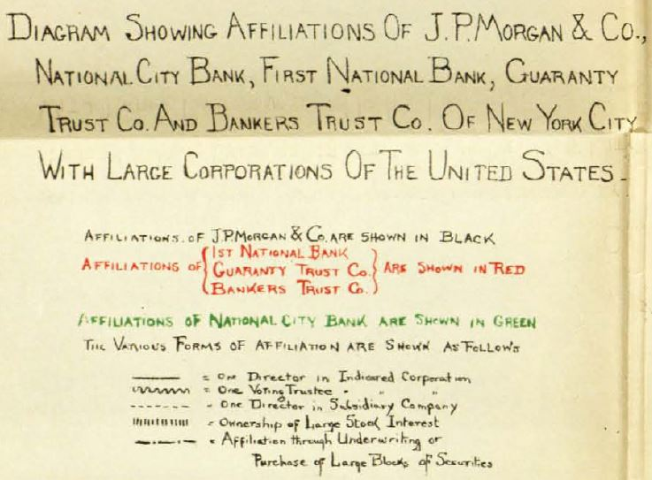
KEY TO DIAGRAM – Exhibit No. 243
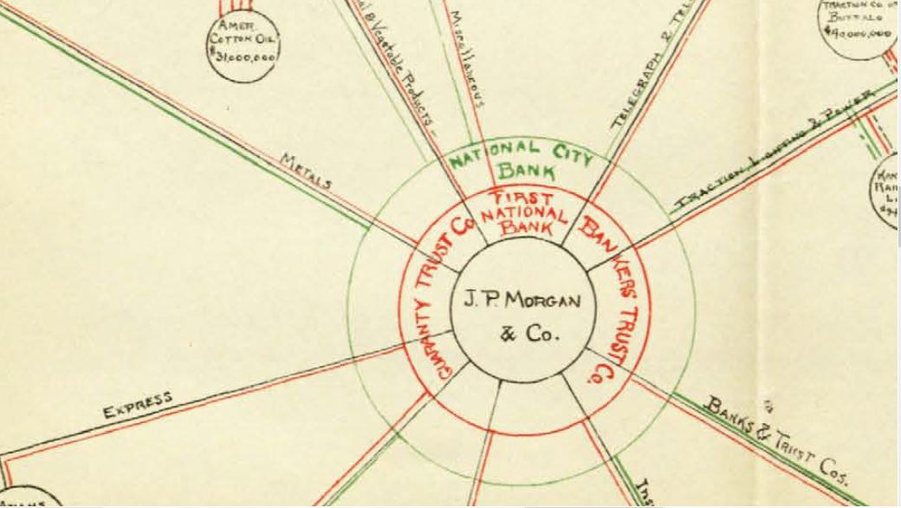
INSERT IN DIAGRAM – Exhibit No. 243
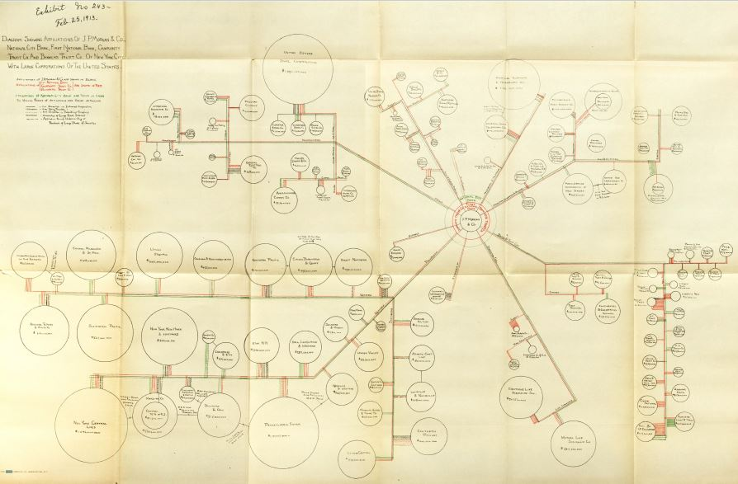
ENTIRE DIAGRAM, Exhibit No. 243

Here is one more exhibit: Exhibit No. 244 (Feb. 25, 1913) entitled:
Diagram Showing Principal Affiliations of
J.P. Morgan & Co. of New York,
Kidder, Peabody & Co. and Lee, Higginson & Co. of Boston,
First National Bank, Illinois Trust & Savings, and Continental & Commercial Bank of Chicago
(27)

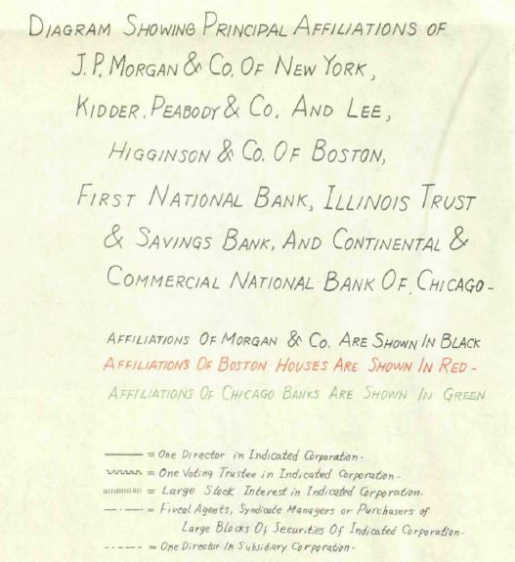
KEY TO DIAGRAM – Exhibit No. 244

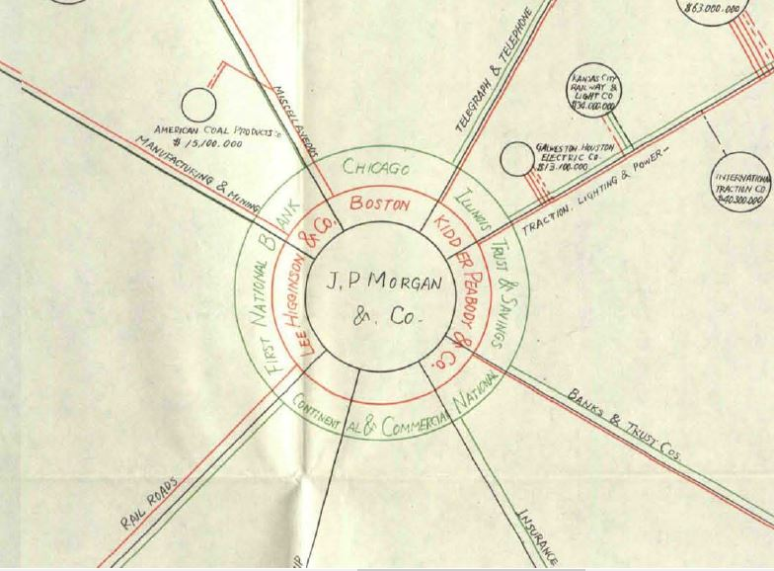

INSERT IN DIAGRAM – EXHIBIT No. 244

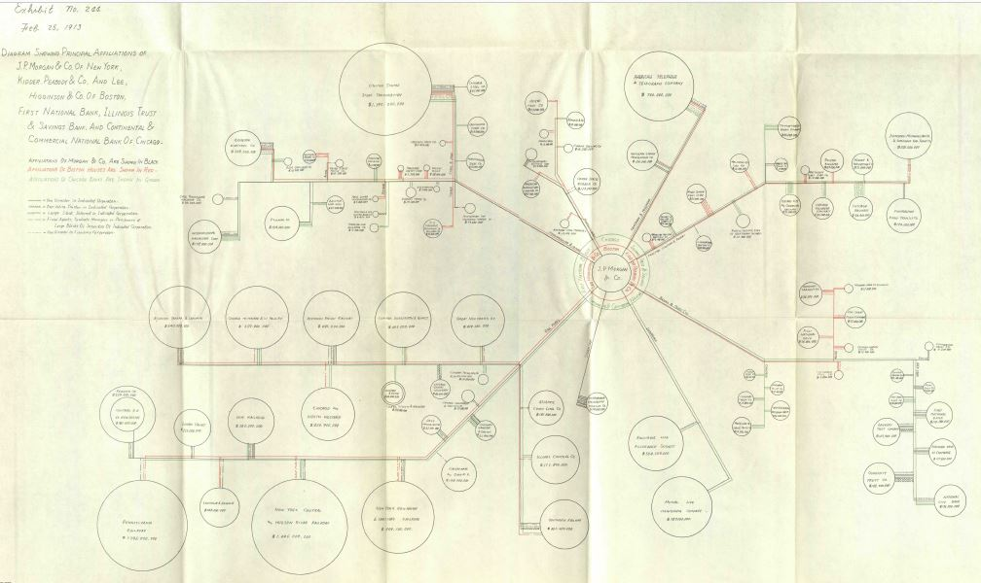
FULL DIAGRAM – EXHIBIT No. 244

II
1913: Creation of the Federal Reserve System

Since 1913, the Federal Reserve has become one of the most powerful financial institutions in the world, and the U.S. Dollar has become the world’s reserve currency. What was the nature of this institution created by the Federal Reserve Act and what powers was it given by the Congress?
The Creation of the Federal Reserve System Was Controversial
Charles Lindbergh Sr., Representative from Minnesota, fought the creation of the Federal Reserve. He publicly identified the real problem: the government had given to private commercial banks the privilege of creating the nation’s means of exchange as debt. He described it succinctly: “The governments have delegated to the rich the privilege of making the money and charging the rest of us for its use.”(28)
On the day the Federal Reserve Bill was signed by President Wilson, Lindbergh declared in Congress: "This Act establishes the most gigantic trust on Earth. When the President signs this bill, the invisible government by the Monetary Power will be legalized…"(29)
So far in the nation’s history, the people had used the publicly-issued monies of the American colonial legislatures, the Continental Congress, and the U.S. Congress, including Civil War Greenbacks, which were serving the true purpose of money─to facilitate exchange. Here are Lindbergh’s words:
Money is the means of exchange among all people. Its regulation is absolutely a governmental function, and the Government has no natural inherent power that enables it to impart to money any other property or quality than that of making it the agent of exchange.(30)
Ordinary people were suspicious of the financiers and big bankers. The ordinary person often lost lifetime savings with the failure of a bank, when banknotes became worthless pieces of paper and deposits disappeared. People wanted the lawful money of Congress.
Government-Issued Money: Lawful Money
By 1913, the state and national governments had set minimum bank reserves for their chartered banks of issue. The reserves were the government money, needed to be kept by the bank, for the conversion of deposits into “cash.”
Congress passed a Gold Standard Act on March 14, 1900, which became the foundation of the American payments system. This act “fixed gold as the standard legal tender monetary metal”(31) and an ounce of gold equal to $18.60. The act began with this declaration:
That the dollar…shall be the standard unit of value, and all forms of money issued or coined by the United States shall be maintained at a parity of value with this standard, and it shall be the duty of the secretary of the Treasury to maintain such parity.(32)

Here is a list of government-issued money under the gold standard:
Gold/silver coins
Gold/silver certificates paper money; represented gold/silver kept on deposit at the Treasury
Greenbacks (U.S. Notes) paper money

The Treasury guaranteed to convert gold certificates and Greenbacks to gold, at the legal rate.
As a practical matter, the silver dollars and silver certificates circulated at par with the gold. The silver dollars and Greenbacks were legal tender for debts. They were also receivable for customs, taxes, and all public dues. People used them interchangeably. They were ‘lawful’ money.
There was one more paper currency that was not lawful money, but which circulated at par with lawful money: national bank notes. The public had confidence in this banknote, since, by law, a nationally chartered bank was limited in the amount of notes it could issue and had to back its notes with Treasury bonds of equal or greater value. As Kenneth Garbade of the New York Fed has written: “The limitation on issuance and the strong backing behind national bank notes left the public confident that the notes could always be exchanged for lawful money.”(33) Milton Friedman and Ann Schwartz also confirmed: “Consequently, national bank notes…circulated at parity with other currency; and we shall have little occasion subsequently to distinguish them from currency issued directly by the Treasury.”(34)
Government-issued money and national bank notes were all acceptable to the public. This was the money they trusted. This was the “real money.”
Growing Call for a “Lender of Last Resort”
Throughout the 19th century, the instability of the private banking system caused a growing awareness of the need for change.
People believed the instability was caused when the public’s demand for currency could not be met. Government lawful money did not expand very much in response to a strong demand for currency. Reformers began to talk about the need for a “lender of last resort” to supply the currency that was needed at times of strong demand, such as at the end of the agricultural harvest when crops were sold, local suppliers paid, and farm hands given their season’s pay.
The business interests of the country also supported this change.
The Federal Reserve Act’s Fundamental Power: An Elastic Currency
Some other currency was needed. So, in 1913, after much controversy, Congress passed the Federal Reserve Act.
The fundamental change made by the Act was “to furnish an elastic currency.” Congress gave to the twelve Federal Reserve Banks (“Fed Banks”) the authority to put into circulation a new banknote called the Federal Reserve Note (“Fed Note”). The Fed Note was an obligation of the national government─a government debt.

Section 16 of the Act says:
The said notes shall be obligations of the United States and shall be receivable by all national and member banks and Federal reserve banks and for all taxes, customs, and other public dues.(35)
A government obligation is a debt that is backed by the full taxing power of the U.S. government, like Treasury bonds and notes. The Fed Note therefore is a government debt, issued as a means of exchange─in parallel to the power given to member banks to create loan deposits, another means of exchange.
The Federal Reserve System is thus a pyramid of debt. The Fed Bank banknotes are a debt to the government; commercial bank credit is debt to the borrower.
Federal Reserve Notes: Backed by Gold

The Fed Banks needed to keep a gold reserve of 40% for redemption of the Fed Notes. Section 16 says:

They shall be redeemed in gold on demand at the Treasury Department of the United States, in the city of Washington, District of Columbia, or in gold or lawful money at any Federal reserve bank… Federal reserve bank shall maintain reserves…in gold of not less than forty per centum against its Federal reserve notes in actual circulation…(36)

From the beginning, a major goal of the System was to get the gold from the hands of the people and from member bank vaults into the Fed Banks. Any excess bank reserves at the Fed Bank could be used to back the issuance of Fed Notes. The more gold in the Fed Banks, the more Fed Notes could be issued.

Note the following passage from a letter, dated February 29, 1916, written by Paul Warburg, one of the major architects of the System and a member of the Federal Reserve Board from its opening in 1914 to 1918. Warburg was writing a “personal and confidential expression of my views” to Representative Carter Glass. Glass was Chairman of the House Committee on Banking and Currency in 1913 and key to convincing the Congress to pass the Act.

All of which goes to show that there is too much gold carried in the pockets of the people and in the vaults of the banks, that there is not enough concentrated in the Federal Reserve Banks and that their lending power today is not sufficient to give us a feeling of reliance in the strength of the system.(37)
Federal Reserve Notes: Backed by Commercial Paper
In addition to the 40% gold backing, 100% of the value of a Fed Note had to be backed by commercial paper in possession of the Fed Bank. Commercial paper were short-term bank loans─to be repaid within three to six months. Their purpose was to fund the real economy of agricultural, industrial and commercial activity, like bringing the country’s yearly production to market or purchasing finished goods for resale.
The title of the Federal Reserve Act directly ties the creation of Fed Notes to the purchase of commercial paper. (The author of this paper has bolded the text.)

AN ACT To provide for the establishment of Federal reserve banks, to furnish an elastic currency,
to afford means of rediscounting commercial paper, to establish a more effective supervision of banking in the United States, and for other purposes.(38)
A bank borrower signs a loan contract, promising to repay a loan plus interest. Since the bank creates a deposit only for the loan amount (the principal)─but not the interest─the bank calls the loan a ‘discount.’ The discount is the interest.
When the Fed Bank buys a member’s loan contract, it is called “rediscounting”. The Fed Bank pays the member less than the contract’s principal and interest. When the contract matures and the loan repaid, the Fed Bank gets full principal and interest. The difference is the Fed Bank’s profit.
This was the mechanism to put the Fed Notes into circulation: the Fed Banks paid the member with Fed Notes whenever possible.
As Fed Notes replaced lawful currency in the hands of the public, lawful money remained in reserves. More bank loans would be possible. The pyramid of debt could expand.
In addition, the Act also gave Fed Banks authority to rediscount members’ loan contracts, secured by the bonds and notes of the Government of the United States. This became very significant for the U.S. government financing of World War I from 1917 to 1919. The government funded the war by selling Treasury bonds, most of which were bought either by people taking out a loan from a bank or by banks buying them directly from the Treasury. As Friedman and Schwartz noted:
World War I produced a correspondingly rapid growth of Federal Reserve money. By 1920, 69 per cent of…[member deposits at Fed Banks] consisted of Federal Reserve notes and deposits.(39)
The Federal Reserve System: Private Control
Was the power to create a public means of exchange being handed over to private interests? Even today the public/private nature of the Federal Reserve System keeps the public confused.
Federal Reserve Board. The Act created a Federal Reserve Board, based in Washington, D.C., composed of seven members. The Board’s role was to set policy and oversee the Fed Banks─to set discount rates and to oversee issuance and redeeming of Fed Notes.
12 Federal Reserve Banks. The country was divided into twelve geographical regions, each with a Fed Bank to contain the reserve accounts of its member banks. When a customer deposited checks in one member bank, the funds coming from another member, the Fed Bank performed the service of ‘check clearing’─moving the reserves between the accounts of the two members.
Each Fed Bank was supervised by a board of directors composed of nine members. Six members were chosen by the member banks and three appointed by the Board.
Each member bank was required to buy stock in their Fed Bank, equal to six percent of the member’s paid-in capital. There were no shares owned by the government.
The Fed Banks would be banks of issue and of deposit: issuing Fed Notes to and accepting deposits from their member banks. The deposits were either reserves of gold and lawful money; national banknotes; or Fed Notes.
Federal Advisory Council. Each Fed Bank board of directors was responsible for appointing a member to the Fed Council, which would meet periodically with the Federal Reserve Board and advise it.
Given the composition of the Federal Reserve Board, the Fed Bank boards, and the Advisory Council, the influence of the private bankers was considerable. From Friedman and Schwartz:
Able and persuasive men at the Reserve Banks exert influence by the weight their views carry in the decisions of the Board or the System as a whole, rather than directly through independent action by the Banks.(40)
Wealthy businessman Irving T. Bush wrote Paul M. Warburg (a banker and one of the important architects of the Federal Reserve Act) with his opinion of the new system, observing the compromises made by the Congress to pass the Act:
In theory, the control of the Federal Reserve Board is general. In practice, the real banking operations of the country will be carried on under the direction of the officers and directors of the Federal Reserve Banks, and the Federal Reserve Board will only exercise control upon certain fundamental questions involving public welfare.(41)
Decades later, the private power wielded by the Federal Reserve System can be found in the words of Marriner Eccles, Chairman of the Federal Reserve Board during the tenure of President Franklin Roosevelt:
Over the years, practices had grown up inside the System which had reduced the reserve board in Washington to impotence. The System had originally been designed to represent a blend of private and public interests… Private interests, acting through the Reserve banks, had made the System an effective instrument by which private interests alone could be served.(42)
The Federal Reserve Act itself supports the private nature of the System:
- The salaries of Board members are paid by assessments on the Fed Banks, not by the government.
- Each Fed Bank pays expenses from its earnings. They do not receive funds from government to function.
The Federal Reserve Act: Concentrating Reserves
At the beginning, the Act made it mandatory that bank reserves be stored only at the member’s Fed Bank or in the member’s vault. In 1917, the Act was amended to mandate that the entire reserve be deposited with the Fed Bank.
The Act thus resulted in a concentration of gold reserves in the Fed Banks. This concentration would allow the issuance of more Fed Notes. More Fed Notes would find their way into the hands of depositors, to replace that “confusing” government money. Paul Warburg addressed this subject in a speech to a convention of bankers in September, 1916:
At the time of the opening of the Federal Reserve Banks, Sir George Paish said to me, ‘The future of your system will depend upon your ability to get under the control of the Federal Reserve Banks the scattered gold of your country.’(43)
These are conditions which, in the long run, may be the cause of heavy gold exports from the United States… If, on the other hand, we forearm, we may grasp the opportunity of taking our place as the strongest of the world’s bankers…(44)
Ultimately we must rid our country of the confusing multiplicity of currency with which we are now afflicted… The circulating currency of the country ought to be silver certificates in the small denominations, and Federal Reserve notes. The best place for gold and gold certificates will be in the Federal Reserve Banks.(45)
…a greenback and a Federal Reserve note are as different as day and night – the one issued as a perpetual currency… and the other issuable… expanding and contracting [with the needs of business]… and secured by a generous minimum reserve of gold…(46)
Triumph of the Bankers
During the banking crisis of 1933, the country went off the gold standard. Reserves of gold and gold certificates were replaced with Fed Notes. Paul Warburg’s plan to make Fed Notes and silver certificates in small denominations the circulating currency had come to pass.
The Fed Act itself included the slow removal of national bank notes from circulation, and in the 1930’s their circulation ended.
The Greenbacks, issued by the government without debt, were slowly phased out of circulation during the remaining years of the 20th century.
Today, our money is Fed Notes, issued by private Fed Banks as a debt, not an asset, of our government. Paul Warburg’s plan to rid the country of the “confusing multiplicity of currency “ had finally come to pass.

III
World War I (1914-17)─U.S. Is “Neutral”:
Federal Reserve System and Gold

Investment Banking Firm of J.P. Morgan & Co. Hired by Britain and France

In the first week of August, 1914, the war began in Europe. On August 9, the firm of J.P. Morgan & Co. asked U.S. Secretary of State William Jennings Bryan if the U.S. government would object to loans being made with the government of France. Bryan advised President Wilson not to support this policy:

Washington, August 10, 1914
My Dear Mr. President:

First: Money is the worst of all contrabands because it commands everything else… I know of nothing that would do more to prevent war than an international agreement that neutral nations would not loan to belligerents. While such an agreement would be of great advantage, could we not by our example hasten the reaching of such an agreement? We are the one great nation which is not involved and our refusal to loan to any belligerent would naturally tend to hasten a conclusion of the war.”(47)

Wilson, however, eventually did decide to permit these loans.

On January 15, 1915, the firm of J.P. Morgan & Co. “signed a Commercial Agency Agreement with the British government by which it entered into a wide range of purchasing and contracting arrangements with American firms in behalf of the United Kingdom.”(48) In May, 1915, France made a similar arrangement with the Morgan firm.

F. William Engdahl describes the effects of these contracts thus:

Morgan served as intermediary for His Majesty’s Government in arranging purchases of munitions, arms, uniforms, chemicals, in short all that would be needed to wage a modern war in 1914. As Financial Agent for the British Government, J.P. Morgan & Co. not only organized the financing of war purchases and decided which companies would be the suppliers, but it also set the prices at which the equipment would be supplied. Not surprisingly, corporations directly in the Morgan and Rockefeller groups of companies were the prime beneficiaries of Morgan’s astute purchasing.(49)

In 1916 alone American industry, despite the nation’s official neutrality, exported a staggering $1,290,000,000 worth of war munitions to England and France. By the eve of America’s entry into the war, J.P. Morgan & Co. had organized the export of some $5 billion worth of war material to the English and French, and later Italian, governments, all bought on credit organized by J.P. Morgan & Co. Such an amount─equivalent to about $90 billion in contemporary dollar value─had never before been transacted by a private bank group.

It was enough to cause a major banking crisis should the loans default.(50)

Effect on the Federal Reserve System

The new Federal Reserve System was ready to support this huge economic upheaval, according to Milton Friedman and Anna Schwartz:

We have used statistical data for June 1914 as reflecting conditions at the outset of the period and for March 1917, at the end. Over that interval of not quite three years [the period of U.S. neutrality], the stock of money rose by 46 per cent and wholesale prices by 65 per cent.(51)

The increase in the stock of money (government money and bank deposits) is reflected in the rise of member bank reserves held in the Fed Banks.

According to the annual reports of the Secretary of the Treasury, as of December 31, 1914, member banks had a total reserve of [roughly $1.5 billion].(52) By March 5, 1917, shortly before the entrance of the U.S. into the war, the reserves stood at [roughly $2.6 billion].(53)

The excess reserves (reserves above the legal requirement) were [roughly $549 million](54) on December 31, 1914 and rose to [roughly $1.1 billion] by March 5, 1917.(55)

How the Allies Paid for U.S. Exported Military Supplies

Sending gold from Europe. The increase of the member banks reserves reflected the huge flow of gold from Europe. During the period of U.S. neutrality, the belligerent nations shipped more than $1 billion in gold to the U.S. to pay for the exported military supplies.(56) Much of this gold found its way into the Federal Reserve member banks and became the basis of the increase in reserves and loans.

Selling their citizens’ U.S. stocks and bonds. In addition, to help pay for the exported military supplies during this same period, the Allies sold, for dollars in this country, $1.4 billion worth of American stocks and bonds owned by their citizens “and transferred under compulsion to government control…”(57) J.P. Morgan & Co. would have been responsible for selling these securities on the U.S. stock and bond exchanges and making hefty fees and commissions.

Borrowing from U.S. investors. Finally, the Allies borrowed about $2.4 billion from the financial markets (the bond markets).(58) J.P. Morgan & Co. would also have been responsible for selling these bonds to U.S. investors and charging their clients as much as they could bear. The Allies, their clients, however, were not in a strong bargaining position.

The Allies raised “a total of no less than $5.3 billion”(59) through these various devices.

The U.S. Becomes a Creditor Nation: Gold and the Federal Reserve

On December 4, 1916, the Honorable William G. McAdoo, Secretary of the Treasury, reported to the nation that the U.S. stock of gold was the largest ever in our history, and indeed ever in the history of any nation:

During the past year the prosperity which set in so strongly during the fiscal year 1915 has grown in strength and volume and is now widely diffused throughout the United States… The financial strength of the United States─the greatest in our history─gives us a commanding position in world finance. We have been transformed from a debtor into a creditor nation. On November 1, 1916, the stock of gold coin and bullion in the United States was estimated at $2,700,136.976, an increase of $714,597,804 in the past 16 months. This is the largest stock of gold ever held in the United States or in any other country of the world.(60)

Through the operations of the Federal Reserve System and with our abundant supply of gold as a basis… we have been able to finance our great domestic and foreign trade without strain and to extend vast amounts of credit to other nations throughout the world… The experience of the past two years has brought into strong relief the value of the Federal Reserve System. It is not too much to say that our great prosperity could not exist without it.(61)

Dear reader, let me remind you that the Federal Reserve System is an edifice of debt. On one level, the private commercial banks create deposits, all as loans to borrowers. On the other level, the private Federal Reserve Banks create Fed Notes, debts of the U.S. government. This is a bank debt system, not a government money system. And this bank debt system was being used to fund a world war, not a regional war!

IV
World War I (1917-18)─U.S. Enters War:
The Federal Reserve System and the Liberty Loans

Debt Drives War: The U.S. Declares War

By the beginning of 1917, the Allies were desperate for more loans from U.S. bankers and investors.

Morgan had extended himself excessively, however, with his own funds direct to the Allies, in addition to selling foreign bonds on the U.S. markets. Reported by the historian Robert Zieger:

Morgan and other financiers extended commercial credit to the Allies, with Morgan by 1917 actually carrying nearly a half-billion dollars of only loosely secured British debt under the heading of ‘short-term’ loans.(62)

The British historian, Burton J. Hendrick, comments:

The British were practically dependent for their existence upon the food brought from the United States, just as the Allied armies were largely dependent upon the steel which came from the great industrial plants of this country. If Great Britain could not find the money with which to purchase these supplies, it is quite apparent that they could not be shipped. The collapse of British credit therefore would have... led to a British surrender, just as effectively as would the success of the German submarine campaign.(63)

In addition, the Russian Czar Nicholas II was dealing with a country increasingly falling apart. This situation made the eastern front against Germany insecure. In February, 1917, riots broke out in Petrograd with shouts of “Down with the war! Down with the Tsar!”(64) If the Russian Empire pulled out of the war, there would be no second front against the Germans. The entire German force would face the Allies on the western front. Allied surrender would be the result.

The U.S. Ambassador to Great Britain, Walter H. Page, was a dyed-in-the-wool lover of the British. He increasingly heard the desperate words from his equals in the British Foreign Office. On March 5, 1917, he wrote President Wilson:

The inquiries which I have made here about financial conditions disclose an international situation which is most alarming to the financial and industrial outlook of the United States… Great Britain and France must have a credit in the United States which will be large enough to prevent the collapse of world trade and the whole financial structure of Europe…

If the United States declare war against Germany, the greatest help we could give Great Britain and its Allies would be such a credit… A great advantage would be that all the money would be kept in the United States. We could keep on with our trade and increase it, till the war ends… We should thus reap the profit of an uninterrupted and perhaps an enlarging trade over a number of years…
Of course, we cannot extend such a credit unless we go to war with Germany…
The pressure of this approaching crisis, I am certain, has gone beyond the ability of the Morgan financial agency for the British and French governments. The financial necessities of the Allies are too great and urgent for any private agency to handle…
There is now an uncertainty about our being drawn into the war… In the meantime a collapse may come.(65)

On April 2, 1917, President Woodrow Wilson went to Congress and asked for a declaration of war against Germany, saying, “The world must be made safe for democracy.”

War Drives Debt: The Liberty Loans

Marriner Eccles, Chairman of the Federal Reserve Board under President Franklin Roosevelt, wrote:

…while the public debt at the time of the Reserve System was created stood at less than $1 billion, when the war ended, the debt was about $27 billion.(66)

The U.S. Treasury offered five war loans to the U.S. public from April, 1917 to April, 1919. Four were called “Liberty Bonds” and the fifth, offered after the armistice in November, 1918, was called a “Victory Liberty Bond.”

Liberty Loans Date offered Amount bought (“Allotted”)

First Apr 24, 1917 2,000,000,000
Second Oct 1, 1917 3,808,800,000
Third Apr 5, 1918 4,176,500,000
Fourth Sep 28, 1918 6,964,500,000
Fifth Apr 21, 1919 4,498,300,000
TOTAL 21,448,100,000(67)
The U.S. Treasury wished to sell the bonds to the public, who would pay with savings. In this way, inflation would be avoided. The public would simply transfer their bank deposits into the account of the Treasury. But Secretary of the Treasury William McAdoo was fearful that not enough bonds could be sold to the public to meet the incredible needs of the war. Historian Charles Gilbert comments:
In order to ensure the full sale of each bond issue, his intention of carrying the campaign directly to the public was changed in practice to greater reliance on bank borrowing, both direct and indirect, inadvertently causing an expansion rather than a diversion of the money supply.(68)

The Federal Reserve System Is Amended
Several amendments were made to the Federal Reserve Law to allow it to create the massive credit expansion necessary to fund the war. Charles Gilbert again:
The Federal Reserve System, committed to the support of the Treasury… with the aid of several amendments to the Federal Reserve Act created the credit expansion potential by means of which the banking system played a major role in financing both the Treasury’s operations and the business expansion which took place at the same time.(69)
Amendment of September 7, 1916: Government Debt as Collateral
[Reader, please note: just as a bank creates a deposit when it makes a loan, it can also create a deposit when it buys a security. The deposit is created in the seller’s account!]
The original Federal Reserve Act did not permit the Fed Banks to make direct advances or loans to member banks but permitted them only to “rediscount eligible paper”─buy members’ commercial loans. With the amendment of September 7, 1916, the Fed Banks were allowed to make direct loans for fifteen days to members, with either commercial loans or government debt serving as collateral. This encouraged the member banks to create deposits for themselves to buy the Liberty Bonds and for their customers to buy Liberty Bonds.
The money supply would expand enormously. More Fed Notes would be put into circulation. Milton Friedman and Anna Schwartz: “Once the United States entered the war, loans on government securities began to rival commercial paper…”(70)
Amendment of June 21, 1917: Changes to Member Reserves
This amendment contained two extremely important changes, which allowed a great expansion of bank funding for World War I.
#1 reduce reserve requirements. First, the reserve requirements of the member banks were reduced. Remember, the legal reserve requirement was the proportion of its deposits that a member was required to maintain as “cash”─gold or government lawful money. On demand, the customer could exchange his deposit for “cash”.
Banks in New York, Chicago, or St. Louis would now have to keep only 13% for a reserve (instead of 18%). Banks in smaller cities had their reserve reduced from 15% to 10%. Country banks, outside the cities, went from 12% to 7%. The result of this change was to permit the banks to create more deposits and either buy government bonds directly or lend to customers to buy government bonds! The money supply would expand. The government would have more funds to fight the war. The banks would make a windfall of profit from interest! And, the government would be more and more in debt.
#2 all bank reserves had to be deposited at the Fed Banks. The original Federal Reserve Act allowed the member banks to keep some part of their reserves outside their Fed Bank─in their own vault or on deposit at another member bank. This was now changed: all reserves had to be kept on deposit at the Fed Banks.
Given the rapid increase in gold reserves─coming over from the Allies to buy war supplies─this gold could now be concentrated in the Fed Banks. This concentration would permit the issuance of more Fed Notes. The result: more private Fed Note currency could be issued to replace the government money in the hands of the people.
The result of these two changes was significant. Between June 20, 1917 and December 31, 1917, the following was recorded by the Federal Reserve Board(71):
- Reserves with Fed Banks increased 73.6%:
from $ 862,000,000
to $ 1,497,000,000
- Investments in government securities increased 65.1%:
from $ 1,065,000,000
to $ 1,759,000,000
- Loans increased 31.4%:
from $ 9,370,000,000
to $ 12,316,000,000

The Increased Powers of the Federal Reserve System

These amendments created a more formidable power in the System.
Beware! The original Federal Reserve Law was “tweaked” here and there, and suddenly the U.S. government was $27 billion in debt!
To give private corporations the power to create the means of payment is to slowly, over time, give up control of our nation. Here is a description by historian Ferdinand Lundberg:
…the total wartime expenditure of the United States government from April 6, 1917, to October 31, 1919, when the last contingent of troops returned from Europe, was $35,413,000,000. Net corporation profits for the period January 1, 1916, to July, 1921, when wartime industrial activity was finally liquidated, were $38,000,000,000, or approximately the amount of the war expenditures. More than two-thirds of…profits were taken by…those enterprises which the [1912-13] Pujo Committee had found to be under the control of the “Money Trust.“(72)
The investment banker was the first creditor to be paid by the U.S. government’s wartime borrowing. As author F. William Engdahl reports, “From the first sales of such Liberty Loans, J.P. Morgan & Co. was paid $400 million to satisfy the [sic] Britain’s debts owed to Morgan. In other words, Wilson used the US taxpayers to pull Morgan’s large chestnuts out of the proverbial fire.”(73)
V
Concluding Thoughts

Origin of the Bank Credit System

The horror and pain of World War I continued for four long and terrible years, for those directly involved with the fighting and their relatives and friends. Millions of people were killed. Millions of people maimed. A generation slaughtered and traumatized.

The bank credit system, where commercial banks create deposits or issue banknotes when they make a loan, with profit to the bank, was the structure of the U.S. monetary system for over a hundred years leading up to World War I.

This system was a European creation, found on both sides of the Atlantic in 1914. The first government-chartered bank of issue was the private Bank of England in 1694. It also made loans by creating deposits or issuing banknotes. It remained a private bank until 1946.

The Bank of England was the beginning of taking the power to create the means of payment away from the government, the only place where this mighty power can be kept under public control. Government-issued money was an asset to the nation; private banknotes and bank credit were debts to the people.

This was the beginning of charging interest (usury) on the nation’s means of payment.

Let all nations teach their people the difference between government-issued money without debt and private bank credit with debt.

Seeds of the Future

Dear reader, while I was researching this paper, I had originally thought to also add a section on the period from 1944 to 1950. In 1944 the Bretton Woods international monetary agreement was signed. This agreement had made the U.S. dollar the world’s reserve currency alongside gold. I searched for how this had happened. The author of the agreement was a U.S. Treasury official called Harry Dexter White, who worked closely under Henry Morgenthau, the Treasury Secretary. But who was influencing Harry Dexter White?

One of the sources I found researching this paper was an article written by David C. Wheelock of the Federal Reserve Bank of St. Louis in November, 2013, “The Fed’s Formative Years: 1913-1929.” In this article, I found the following:

[World War I] disrupted European financial markets and reduced the supply of trade credit [loans] offered by European banks, providing US banks with an opening. Low US interest rates, abundant reserves, and new authority to issue trade acceptances [create deposits for loans to exporters and importers] enabled American banks to finance a growing share of world trade. By the second half of the 1920s, over half of US imports and exports were financed by dollar-denominated acceptances, as was a large share of the international trade of other countries (Eichengreen 2011, p.30). The strength of the US economy and the greater use of the dollar for making international payments made the dollar the world’s leading reserve currency; by the mid-1920s, foreign governments and central banks held more of their foreign-exchange reserves in dollars than in any other currency (Eichengreen 2011, p.32).(74)

Here was the source of the U.S. Dollar as today’s world’s reserve currency. And it was another couple of “tweaks” of the Federal Reserve Law back in World War I. Watch those tweaks!

THE NEED ACT, HR2990

I am hoping that this paper can explain to people why this system must be abolished, for the sake of mankind on our planet. During most of our history, government controlled the power to create the means of exchange as an asset, without interest. It worked much much better than this bank credit slavery.

Please visit monetary.org, the website of the American Monetary Institute (AMI). This organization worked with Representative Dennis Kucinich for several years to prepare a monetary reform bill for Congress. This bill, the NEED Act (National Emergency Employment Defense Act, HR2990), was introduced into Congress two years in a row. It would, with very little disruption to the current society, change the bank credit system back into a government money system.

I thank the American Monetary Institute for giving me the opportunity to prepare this research for them. It is an honor, and I am grateful for how much I have learned about our monetary system by doing this work.

Susan M. Peters
New York, New York
nychollis@use.startmail.com

“Nearly all wealth is the production of labor; therefore, laborers would have possessed
it, had not something intervened to prevent this natural result.”(75)

Edward Kellogg, 1883, Labor and Capital; A New Monetary System─from the Preface

“The most important fundamental law in any nation is that which institutes money;
for money governs the distribution of property, and thus affects in a thousand ways
the relations of man to man.”(76)

Edward Kellogg, 1883, Labor and Capital; A New Monetary System─from the Introduction

