http://www2.uncp.edu/home/rwb/uncp_bar.gif

**Amsterdam in the Seventeenth Century**

**The Bourgeois Baroque Style**

**The Plan of the Three Canals**

    The year is 1610, and the fathers of Amsterdam have approved the Plan of the Three Canals, a major urban planning project.  It will expand the size of the city from 450 to 1,800 acres.  This expansion was made necessary by a dramatic growth in population, some of whom were refugees from areas controlled by the Spanish, while others were intellectuals and Jews who moved to Amsterdam because there was no persecution there.  The population in 1567 was 25,000; in 1610: 50,000; in 1620: 100,000; and in 1660: 200,000.  Other indicators of the growth of Amsterdam are the founding of  a "chamber of assurances," which provided marine insurance policies in 1598, the founding of the Dutch East India Company in 1602, the opening of the Bourse, or Stock Exchange, in 1608, and the creation of an exchange bank in 1609 and a lending bank in 1614.  Seventeenth-century Amsterdam was thus a center of shipping, shipbuilding, and trade.  Some called it the "marketplace of northern Europe," because of its warehouses, its wholesale dealers, its insurance agents, and its brokerage houses.  It was also the industrial capital of the Dutch Republic.  It imported raw materials and exported finished silk, leather, wool, and tobacco products; its was noted for its printing presses, its gun foundries, and its shops for grinding lenses.

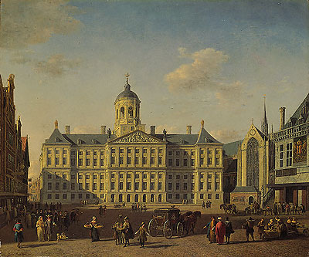Berckheyde, *The Town Hall, Amsterdam*.

    The Plan of the Three Canals, which was the result of cooperation by the Director of City Works and a master mason, carpenter, and sculptor, combined aesthetic appeal, a concern with sanitation, and an interest in the economic function of the city.  It called for the digging of three great semi-circular canals, links between them and existing canals with radial canals, the erection of buildings on pilings, sanitary arrangements for each house and a network of drains and sewers, and the construction of merchants' houses with storage facilities on the upper floors and warehouses near the mouth of the Amstel.  The city government assumed the responsibility for carrying out this plan.  It expropriated the land, dug the canals, and laid out lots for sale to private individuals for housing, thus allowing the government to recoup the cost of building the three canals.  Each canal was about seventy-five feet across, which provided space for two-way traffic and a lane for moored boats.  The canals were bordered by quays about thirty-three feet wide for loading and unloading, and they were planted with elm trees.  Between the canals were building plots with narrowing fronting on the canals and a depth of about 150 feet.  The inner canal (the *Heerengracht*) was 3.5 kilometres in length; the middle canal (the *Keizersgracht*) was 4 kilometres, and the outer canal (the *Prinsengracht*) was 4.5 kilometres.  These canals, together with existing facilities, allowed some 4,000 ships to be docked at any one time.  Although the building plots were regular and the houses on the canals of approximately the same width, the facades and the gables showed variety and individuality.  But, since the canals could not be viewed panoramically and because the trees lining the canals often obstructed one's view, much of the city was seen as a connected set of vignettes.  According to a contemporary Frenchman, "Among the large town, Amsterdam is the most beautiful I have seen."

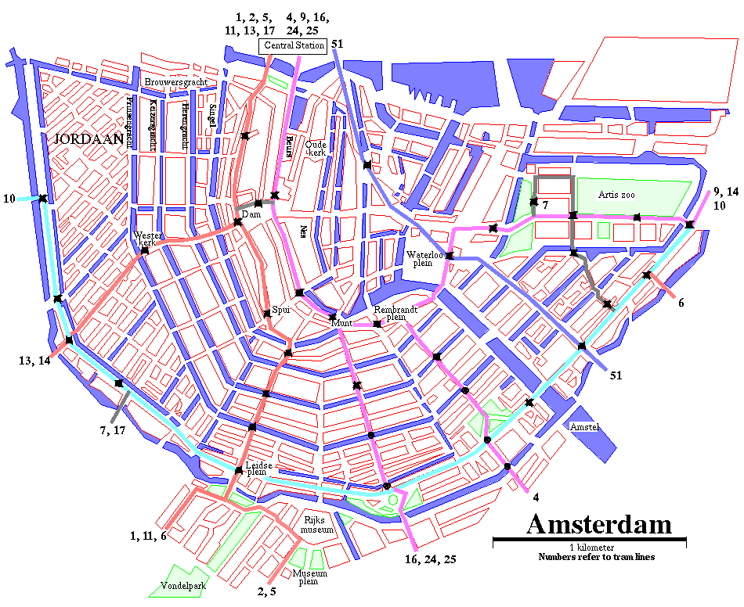

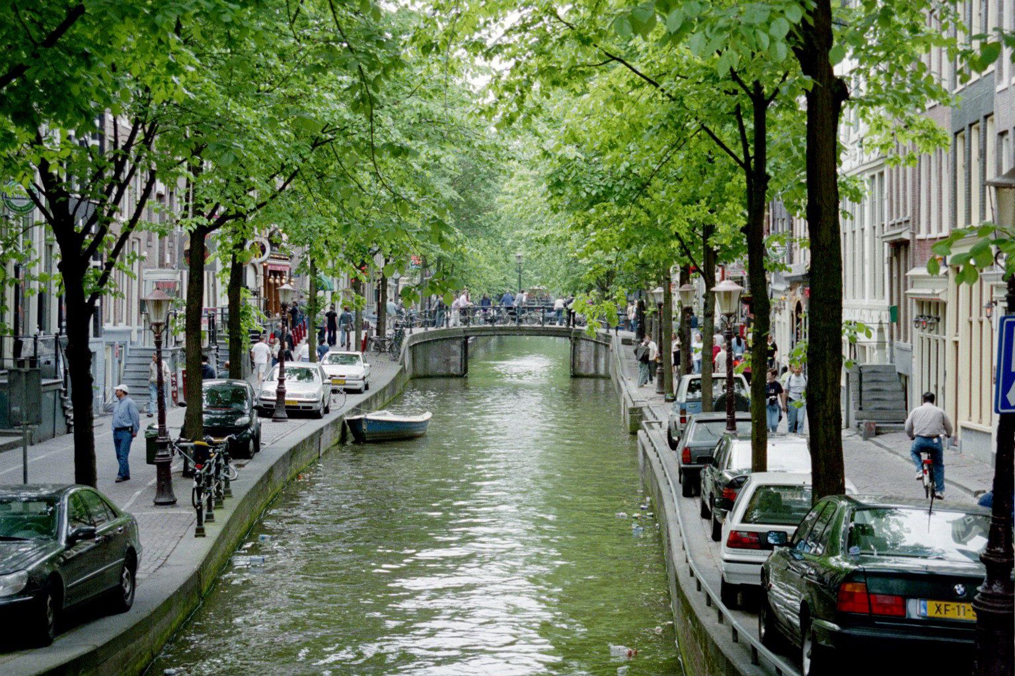

**The Dutch Way of Life**

    The Dutch way of life was unique in seventeenth-century Europe.  In religion, the city was Calvinist, but the Dutch did not attempt to turn Amsterdam into another Geneva, and they practiced a degree of religious toleration unknown elsewhere in Europe.  They had political freedom, which they had won at great cost during the wars with the Spanish.  They lacked natural resources, but they were able to make Amsterdam into the world's greatest trading center and into an important center of manufacturing.  The Dutch found ways to make profits from the incessant wars of the 17th century.  Moreover, they built a colonial that rivaled that of the Spanish and surpassed that of the Portuguese.  And, last but certainly not least, they provided a context for a great cultural flourishing, one that is associated with the name of Rembrandt, to mention only the most famous Dutch artist of the seventeenth century.  Further, the Dutch turned home life into a work of art, and they then supported artists who painted that same home life.

**The Historical Context**

    A series of complex events which historians call the Revolt of the Netherlands (1566-1648) allowed Amsterdam to emerge as the dominant city in the Low Countries.  The seven northern provinces of the Netherlands (17 provinces in all) rebelled against Spanish rule and won political independence in 1609.  In the war with Spain, the Spanish armies commanded by the Duke of Alva destroyed Amsterdam's economic rivals in the south, including Antwerp.  Accordingly, Amsterdam's freedom and her large population made her the de facto capital of Holland.

    In addition to possessing political independence, Amsterdam was a major hub of European commerce after 1609.  One reason was the decline of Antwerp, which was during the sixteenth century a center of banking and international commerce.  The decline began in 1576, when the city was sacked by Spanish troops and some 6,000 citizens killed.  To make matters worse, Antwerp was occupied in 1585 following a fourteen month siege, which had closed her ports and stopped trade.   
Economic Basis for Amsterdam's Prosperity

    Amsterdam, first of all, welcome refugees, including a significant number who had fled Antwerp, bring capital and commercial skills with them.  Secondly, merchants in Amsterdam were eager to seize opportunities to make money.  These included purchasing grain and other foodstuffs in Poland and eastern Europe and selling food to those experiencing shortages.  The Dutch developed industries to supply export goods to colonies, a practice not followed by the Spanish and Portuguese, who then had to purchases such goods as textiles, metalwork products, armaments, furniture, rope, tar, timber, and other items.  Third, they were willing to take risks and plunder Spanish and Portuguese treasure fleets.  They also built ships to sell or lease and outfitted ships purchased elsewhere.

**Amsterdam's Advantages.**

    Amsterdam had a superb merchant marine and the means to protect its ships.  About 1650, the Dutch owned 50% of the merchant ships in Europe.  Dutch merchants were prepared to trade in virtually any commodity in world commerce.  Accordingly, Amsterdam prices became a world-wide reference guide.  Further, the Dutch provided a complete assortment of commercial services, ranging from credit to insurance to brokering to law.  The Dutch were hard working and efficient.  Ships that berthed in Amsterdam harbor could unloaded and reloaded within a few days.  In Amsterdam, a merchant could purchase just about anything, including grain, naval supplies, armaments, and fish.  Moreover, the Dutch controlled metal imports from Sweden, wool from Spanish sheep, salt from Denmark, and unfinished woolen clothing from England.  Many of these imports were raw materials or semi-finished goods.  They were then finished in Amsterdam and exported at a considerable profit.

**Amsterdam's Overseas Trading Companies**

    The ambition of Dutch merchants was to break the monopoly held by Spain and Portugal over the spice trade.  To this end, the Dutch founded the Company of Far Lands, and the Dutch managed to penetrate the East Indes and establish trading relationships.  As the trade thrived, the Dutch found they were competing against each other, thus harming themselves.  To put an end to this situation, the Dutch founded the United Netherlands Chartered East India Company in 1602; its initial capital was 6.5 million florins, 50% of which came from Amsterdam.  This company claimed a monopoly over trade from the Cape of Good Hope to the Straits of Magellan.  It could make war and peace, build fortresses, seize foreign vessels, and coin money.  Amsterdam merchants dominated the Company.  An annual fleet was sent out, and it seized areas in which the Dutch wished to trade, including Cape Town, parts of India, Batavia on Java, the Moluccas, and Nagasaki, Japan.  In 1621, the Dutch West India Company was founded to monopolize trade with the New World.  Its captured the entire Spanish treasure fleet in Cuba in 1628.  They also tried but failed to colonize New York.  The result of the activities of the East and West India Companies was a vast increase in the quantity as well as the quality of the goods available.  The character of the Dutch merchants who thrived in this competitive atmosphere was calculating, greedy, tight-fisted, and frugal; they were ready to forego immediate pleasures for long-term gain, and they often ignored religion and patriotism when they interfered with economic activity.  According to the contemporary poet, Joost van der Vondel:  "For love of gain the wide world's harbors we explore."

**Amsterdam as a Financial Center.**

    Amsterdam had at its disposal large amounts of capital and the means for its investment.  Some of it came from the savings of merchants, some from the money refugees brought with them, some from money made by merchants in the 17th century, including those clever enough to profit from the wars of the 17th century.  According to a contemporary burgomaster, "It is known to all the world that whereas it is generally the nature of war to ruin the land and people, these countries [the Netherlands] on the contrary have been noticeably improved thereby."  But there need to be ways to invest money, and the Amsterdam city fathers founded and supervised the Amsterdam Exchange Bank, the safest and the most reliable and efficient bank in northern Europe.  Wrote an English nobleman: the bank's reputation was "another invitation for People to come, and lodge that part of their Money they could transport, and knew no means of securing at home.  Nor did [only] those people lodge Moneys here, who came over into the Country; but many more, who never left their own; Though they provided for a retreat, or against a storm, and though no place so secure as this, nor from when they might so easily draw their Money into any parts of the World."  The city also founded the Amsterdam Lending Bank, which offered 3% loans to its best customers.  Finally, there was the Amsterdam Stock Exchange, which became a center for commodity trading.  Overall, Amsterdam's economy was structured to create wealth, the Dutch enjoyed the highest per capita income in Europe, but such wealth was not equally distributed across the spectrum of social classes.

**Amsterdam's Social Structure**

    Bottom of the social order were the class called the *grauw*, the rabble, which include those ranging from the impoverished elderly who had to beg to unskilled day workers, many of them drawn by Holland's reputation as a place of wealth.  These people were on the fringe of orderly Dutch society, and the city of Amsterdam dealt with by charity and by force and the threat of swift and brutal justice.  Torture, the pillory, and execution were common, and a gallows stood at each city gate.

    The class called the *kleine* man was made by artisans and manual workers.  Most were members of a minor guild or were employed by guild members, many of whom operated shops employing 6 to 10 workers.  This class inhabited the area called the Jordaan.  Housing was crowded, but there was a rich working class culture that attracted artists like Rembrandt, de Hoogh, and Hobbema.

    Above the artisans and workers were the middle-class professionals.  Calvinist ministers, lawyers, teachers, company bureaucrats, and members of the more affluent guilds. And above them were the landed nobility, many of whom owned town houses.

    At the peak of Amsterdam's social structure were a small group of very wealthy merchants, which included the heads of large companies, large manufacturers, and shipyard owners.  This group had led the revolt against Spain, and from the time of Dutch independence on, they controlled the government of Amsterdam and the Seven Provinces.  Their houses lined the new canals.  These wealthy burghers lived in simple dignity and they avoided ostentatious displays.  They wore dark clothes (of the best quality), decorated with a ruff for men and lacework for women.  Home furnishings were solid and sturdy; floors had tile or marble; and cleanliness was the rule.

**The Government of Amsterdam**

    During the first half of the 17th century, the government of Amsterdam was in the hands of a merchant oligarchy, and their overriding goal was to further economic progress.  Making up the government were a sheriff, four burgomasters, nine alderman, and thirty-six city councillors, all known as the regents.  These officers were controlled by the great merchant families, who also controlled the government of the Province of Holland and the States General of the Dutch Republic.  During the early 17th century, this merchant elite was challenged by the more radical Calvinists, but they failed to control political and economic activities outside of the church.  The rule of the merchant elites was also challenged by the House of Orange, members of which aspired to become kings.  The held the office of stadholder and they commanded the armed forces.  Support came from the lower classes and the Calvinist preachers.  Nevertheless, the regents managed to hold the stadholders at bay.  During the second half of the seventeenth-century, the government of the Regents declined.  Bribery, nepotism, and corruption became commonplace, while the economic interests of the Regents changed.  Many turned from commerce to real estate and investments, and they often came into conflict with the merchants.  In any case, the power and prosperity of Amsterdam and Holland declined begining in the late seventeenth century.

**Dutch Painting in the Golden Age of Rembrandt**

    Unlike elsewhere in Europe, the patrons of the arts in Amsterdam were the middle and commercial upper classes.  They accordingly avoided the history and mythological pictures favored by aristocratic and religious elites.  Instead the Dutch favored landscapes, which symbolized the ownership and cultivation of the land; townscapes, which reflected their values of order and decorum; Biblical subjects, which were drawn from the New Testament and emphasized the parables, teaching, and preaching of Jesus; genre scenes, which depicted every day, still lifes, which both depicted tastefully arranged collections of flowers and other objects and which often served as *momenti mori*;

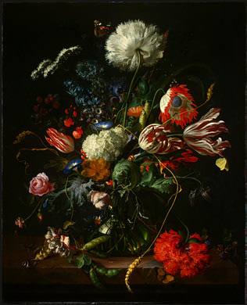Jan Davidsz de Heem, *Vase of Flowers*

corporation picutres, like *The Night Watch* of Rembrandt;

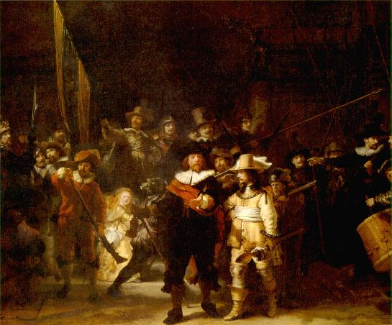Rembrandt, The Night Watch

and portraits of wealthy merchants and their families.  In short, paintings dealt with the household, the marketplace, and the place of business, all centers of Dutch life.  The characteristics of Dutch painting can be seen by comparing the art of Rembrandt (1609-1669) with that of Jan Vermeer.  Rembrandt's art is noted for its breadth of vision, its power of characterization, the psychological death of his insight, the dramatic intensity of his religious pictures, and by the power of his light, which he uses to illuminate character, define space (with bright colors), or give life to space (with shadows).  Among his best known works are *Dr. Tulp's Anatomy Lesson*, which reflects the advances of the Scientific Revolution, *The Night Watch*, his self-portraits, which form a painted autobiography.

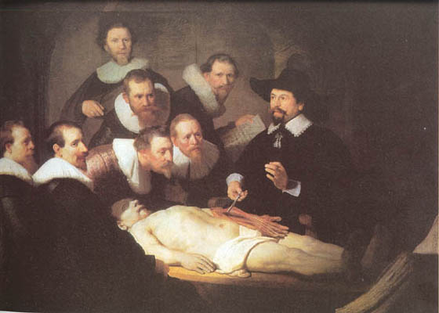Rembrandt, *The Anatomy Lesson of Dr. Tulp*.

In contrast is the work of Vermeer, known for the *View of Delft* and numerous interiors of Dutch houses.

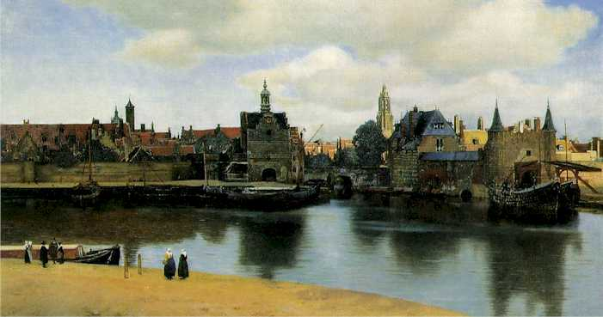Vermeer, *View of Delft*.

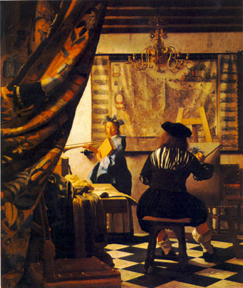Vermeer, Dutch Interior (*The Allegory of Painting*).

Vermeer's work is characterized by sobriety and an objective detachment; a cool and impersonal nature; physical perfection like a piece of fine jewelry; the absence of drama and conflict.  But whether the paintings are by a Rembrandt or a Vermerr or the dozens of other fine Dutch painters of the seventeenth century, they all mirror the values of Dutch civilization at its height.

**Dutch Topographical Painting**

    Dutch townscape and architectural painting flourished between the 1650s and about 1700 within a specific historical and cultural context.  Effectively gaining independence from Spain in 1609, the Dutch rapidly became a leading economic power.  Emblematic of this prosperity was the tidy appearance of the Republic's expanding towns and cities, with their paved streets, canals, and substantial but not ostentatious public and private buildings.  Taste for views of these towns expressed not just national or civic pride but also quiet satisfaction with the creation of an orderly and aesthetically pleasing built environment and in the common political, economic, and religious values it represented.  The topographical townscape, with its confident, serene, and detailed description of a harmonious world planned and constructed by man, accordingly mirrored Dutch perceptions of their urban environment.

    Topographical painting in Holland developed in keeping with trends elsewhere in Europe and, by the first half of the seventeenth century, drawings of actual towns, church interiors, and ensembles of buildings had begun to appear.  Important in this transition were Claes Jansz. Visscher (1587-1652), Jan Abrahamsz. Beerstraaten (1622-1666), and others, but the central role belonged to Pieter Jansz. Saenredam (1597-1665).  Although church interiors predominate in his paintings and drawings before the 1650s, he made detailed drawings of building exteriors and groups of buildings in Amsterdam, Utrecht, and other cities in the 1630s and 1640s, from which paintings were made two decades later.  The Old Town Hall, Amsterdam (City of Amsterdam, on dep. Rijksmuseum) and The Mariakerk and the Mariaplaats, Utrecht (Rotterdam, Mus. Boymans-Van Beuningen), illustrate the clarity and precision of Saenredam's buildings, his calm disposal of building clusters, and a detached preoccupation with architecture that minimizes the human dimension of the urban environment.   
    
    Beginning in 1650s, Gerrit Adriaensz. Berckheyde (1638-1698) and Jan Jansz. van der Heyden (1637-1712) devoted themselves almost exclusively to painting topographical views of Haarlem, Amsterdam, and The Hague, as well as Cologne and other cities.  Their subject was, for the most part, the modern city and its life, and favoured sites included the Grote Markt in Haarlem, the new Town Hall and the Flower Market in Amsterdam, along with views of squares, streets, or canals.

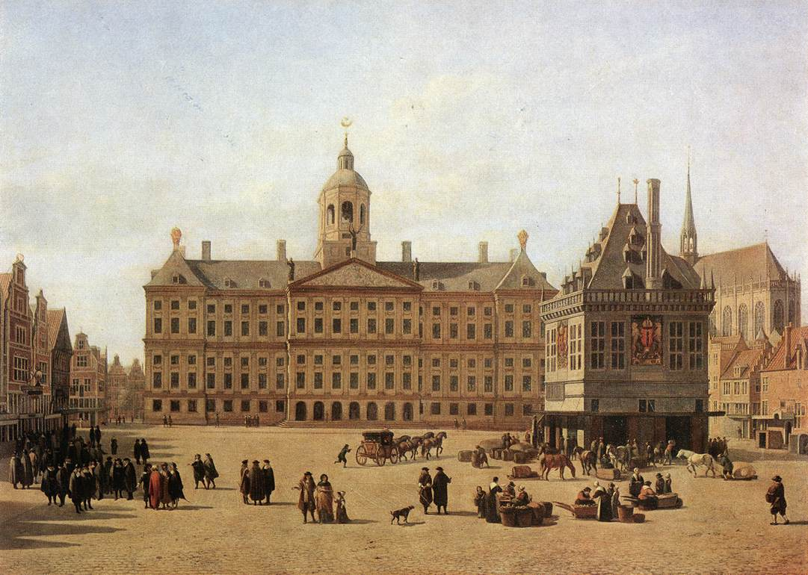  
Berckheyde, *The Dam in Amsterdam*.

Portrayed in Berckheyde's *The Market Place* and the *Grote Kerk* at Haarlem (London, National Gal.) are not only elegant buildings harmoniously arranged around an open square but also characteristic types of human activity integrated with the built environment.

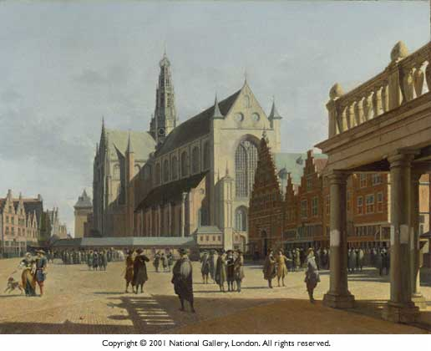Berckheyde, *The Market at Haarlem*.

The view and the buildings chosen suggest intersecting political, commercial, and religious themes, while the painting itself embodies the values of order and decorum.  Van der Heyden's atmospheric town views, often more detailed but less topographically accurate than those of Berckheyde, include depictions of the Heerengracht in Amsterdam and the Oudezijds Voorburgwal with the Oude Kerk in Amsterdam (The Hague, Mauritshuis).   
    
    Artists contemporary with Berckheyde and Van der Heyden often turned to architecture or the townscape.  Notable for church interiors were Gerrit Houckgeest (c.1600-1661), Emanuel de Witte (c.1616/18-1691/92), and Hendrick van Vliet (1611/12-1675), who created a style more dramatic and animated than that of Saenredam.  Active also were print makers, like Reinier Zooms, called Zeeman (c.1623-c.1667) and Jan van Call (1656-1703), and artists such as Jan Wijnants (1632-1684), whose topographically correct View of the Heerengracht in Amsterdam (Cleveland, Mus. of Art) is exceptional for its focus on the canal itself.  Landscape artists like Meindert Hobbema (1638-1709) occasionally painted towscapes, as did Jacob van Ruisdael (c.1628/29-1682), who depicted The Damrack in Amsterdam.  And widely acclaimed are Jan Vermeer's (1632-1675) only townscapes, the *View of Delft* (The Hague, Mauritshuis) and *The Little Street* (Amsterdam, Rijksmuseum).  Cityscape painting continued into the next centuries, but with little added to the established tradition by artists like Izaak Ouwater (1750-1793), whose *View of the Westerkerk* (Ottawa, National Gal. of Canada) is exact but dry.

**Economic Decline**

    From the second half of the 17th century on, Amterdam and Holland suffered an economic downturn.  Commercial innovation came to an end, industrial productivity dropped, and the population stagnated for a century and a half.  A number of factors coincided to bring about the decline.  First, overseas commerce was emphasized at the expense of industrial development.  Before 1650, money made in industry was invested in commercial activities; after 1650, money made in commerce was used to purchase land or securities.  Hence there was no industrial revolution.  Second, skilled workers were often lured away from Holland by the offer of higher wages.  Third, tax rates were relatively high, more than three times the English rate, for example.  Fourth, Holland was forced to fight a series of expensive wars.  Fifth, there were the activities of Holland's rivals.  Amsterdam's economic had been based on service as middle-men, and this was threatened when other countries began to engage in the activities they had paid the Dutch to perform.  Both Britain and France built their own merchant marines, thus depriving the Dutch of this source of revenue.  Dutch fishing grounds were invaded by foreign rivals, including the English, the Scots, the Scandinavians, and the Belgians.  Over time, the Dutch lost the luxury trade to the French and the mass trade to the English.  Even Dutch agriculture declined.  Sixth, the economic policy of mercantilism brought difficultires.  According to the proponents of mercantilism: bullion is the basis of national wealth; to accumulate wealth, a nation must maintain a favorable balance of trade; the amount of wealth in the world is limited, so an increase in wealth for one nation means a decrease for others; and colonies are a source of raw materials and are captive markets for the sale of goods produced in the mother country.  If these premises are accepted, then state intervention in the economy is necessary; i.e. to maintain quality, to found new industries to increase exports, and to seize and maintain control of colonies.  But Holland lacked the sort of strong central government that was developing in England and France, governments who were willing to use military power in pursuit of economic objectives.  Hence wars with England in 1652-1654, 1665-1667, and 1672-1674 and with France 1672-1678.  In essence, Holland was a victim of English and French mercantilistic policies.  And, as noted above, these wars were expensive, they produced much damage, and they sapped Dutch energy.

**Conclusion**

    So for a brief moment, Amsterdam flourished, and a wonderful city was the result.  In addition, the Dutch provided an atmosphere in a Europe were intolerance was the norm.  And, the Dutch built a thriving culture, demonstrating that dignified middle class restraint could be as great a virtue of a civilized people as the exurberant magnificance of Baroque Rome or Louis XIV's Paris.

This Page is Maintained by Robert W. Brown   
Last Update: 30 March 2004

[**Return to Robert W. Brown's Home Page**](http://www2.uncp.edu/home/rwb/index.html)

[Return to the History Home Page](http://www.uncp.edu/history/)